**Group 4 – WAH for Hospitals (WAH4H)**

“A PROPOSED MODULAR HOSPITAL INFORMATION SYSTEM (HIS) WITH INTEGRATED E-CLAIMS AND ELECTRONIC HEALTH RECORDS (EHR) FOR MUNICIPAL AND COMMUNITY HOSPITALS”

**Scrum Master:**

Nicolas, Jhon Lloyd

**Members:**

Chavez, Mariyah Vanna Monique

Jajurie, John Kenneth

Quibin, Elijah Josh

In Partial Fulfillment of the Requirements for Systems Analysis and Detailed Design

SSYADD1 SS231

Mr. Jose Eugenio L. Quesada

A.Y 2025-2026 1ST Term

TABLE OF CONTENTS

Stage 1: Empathize 5

* 1. Introduction 5
  2. Client Interview 8
  3. Customer Interview 11
  4. Actual Personas 13
  5. Theoretical Personas 15
  6. Empathy Map 17
  7. Pain-Gain Analysis Summary 19

Stage 2: Define 19

* 1. Clustered Problems 19
  2. Problem Statement 21
  3. How-Might-We 22

Conclusion 23

Stage 3 – IDEATE 24

* 1. Brainstorming Session 24
  2. Crazy 8’s 26
  3. Post It Voting 31
  4. Desirable, Viable, Feasible. 32

Stage 4: Prototype 35

* 1. Story Boards 35
  2. Wireframe 40
  3. Mockup Design 47

Conclusion 53

Stage 5: Testing 53

* 1. Client Feedback 55

TABLE OF FIGURES

TABLE OF FIGURES 3

Figure 1 Speed Up Garage's Physical Location 5

Figure 2 Interview Location/ Admin Room of Speed Up Garage 6

Figure 3 Interview with Ma’am Mica (Cashier and Inventory Head of Speed Up Garage) 6

Figure 4 Interview with Ma’am Maria and Sir Rosmel Lingon (Owner of the Speed Up Garage) 8

Figure 5 Interview with Speed Up Garage Customer 11

Figure 6 Actual persona 1 of Speed up Garage Owner 13

Figure 7 Actual persona 2 of Speed up Garage Owner 13

Figure 8 Actual Persona 3 of Employee 14

Figure 9 Actual persona 5 of Customer 14

Figure 10. Theoretical Persona 1 of Owner 15

Figure 11. Theoretical Persona 2 of Employee 15

Figure 12. Theoretical Persona 3 of Customer 16

Figure 13. Theoretical Persona 4 of Customer 16

Figure 14. Owner’s Empathy Map 17

Figure 15. Owner’s Empathy Map 17

Figure 16. Employee’s Empathy Map 18

Figure 14. Customer’s Empathy Map 18

Figure 15. Pain and Gain Analysis Summary 19

Figure 16. Trello board screenshot of clustered problem 21

Figure 17. Trello board screenshot of Problem statement 22

Figure 18. Trello board screenshot of How-Might-We 23

Figure 19. Brainstorming meeting screenshot 25

Figure 20. Trello board screenshot of brainstorming 26

Figure 21. Figma platform screenshot 27

Figure 22. Esurena Crazy 8’s screenshot 27

Figure 23. Reyes Crazy 8’s screenshot 28

Figure 24. Rocha Crazy 8’s screenshot 29

Figure 25. Saguinsin Crazy 8’s screenshot 30

Figure 26. Trello board screenshot of post it voting 31

Figure 27. Trello board screenshot of Desirable 32

Figure 28. Trello board screenshot of Viable 33

Figure 29. Trello board screenshot of Feasible 34

Figure 30. Story board for cashier 36

Figure 31. Story board for login 36

Figure 32. Story board for generating reports 37

Figure 32. Story board for inventory 37

Figure 32. Story board for inventory 38

Figure 34. Story board for debt 38

Figure 34. Story board for debt 39

Figure 34. Story board for debt 39

Figure 37. Wireframe for login system 40

Figure 37. Wireframe for login system 40

Figure 39. Wireframe for POS dashboard 41

Figure 40. Wireframe for POS sales 41

Figure 41. Wireframe for POS - Scanning Terminal 42

Figure 42. Wireframe for POS - products 42

Figure 43. Wireframe for POS - Reports 43

Figure 44. Wireframe for POS – daily sales report 43

Figure 45. Wireframe for inventory – daily reports 44

Figure 46. Wireframe for inventory dashboard 44

Figure 47. Wireframe for inventory 45

Figure 47. Wireframe for inventory 45

Figure 49. Wireframe for inventory - out of stocks 46

Figure 50. Wireframe inventory - reports 46

Figure 51. Mockup Design for Login System 47

Figure 52. Mockup Design for Dashboard for admin 47

Figure 53. Mockup Design for POS - Dashboard 48

Figure 54. Mockup Design for POS - Sales 48

Figure 55. Mockup Design for POS – Scanning terminal 49

Figure 56. Mockup Design for POS - Products 49

Figure 57. Mockup Design for POS - reports 50

Figure 59. Mockup Design for Inventory dashboard 50

Figure 59. Mockup Design for Inventory dashboard 51

Figure 60. Mockup Design for inventory - low stock 51

Figure 61. Mockup Design for Inventory – out of stock 52

Figure 62. Mockup Design for Inventory - Reports 52

Figure 63. Feedback and Testing with Sir Ross Mel Lingon 54

Figure 64. Feedback and Testing with Ma’am Maria and Ma’am Micah 54

# Stage 1: Empathize

## **Introduction**

At this stage of the design thinking process, we begin by thoroughly understanding the needs and experiences of the people we are designing for. Our focus is inpatient modules in healthcare, we would like to understand the needs of the healthcare staff, billing staff, and hospital administrators. We conduct thorough research and observations to learn about the people we are designing for. The goal is to build empathy by seeing things from their perspective—not just understanding what they say, but also what they do, think, and feel. This involves active listening, asking open-ended questions, and immersing ourselves in their experiences. Through this process, we uncover key insights and identify problems or challenges that need attention.

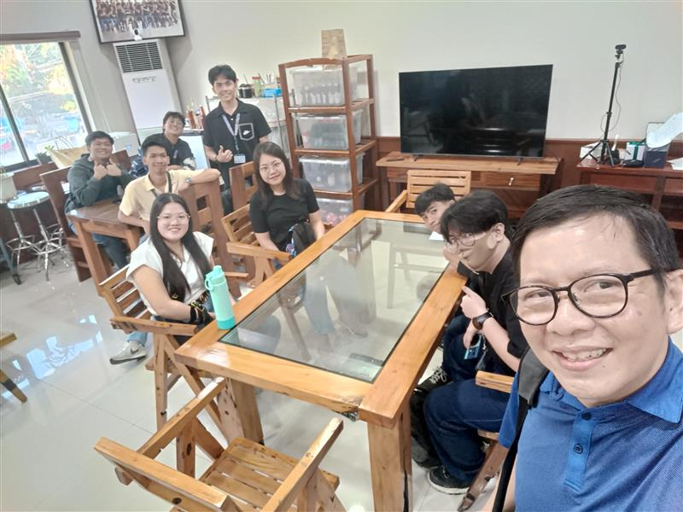

Figure 1: Wireless Access for Health (WAH) Headquarters

Two representatives from our team visited the site of Wireless Access for Health (WAH), located on the 2nd Floor, Diwa Ng Tarlac, Tarlac City, 2300 Tarlac. They took the initiative to meet with our clients to understand their thoughts and perspectives on the organization’s mission. The primary purpose of the visit was to immerse themselves in the actual workplace and observe the workflow of the healthcare facilities.

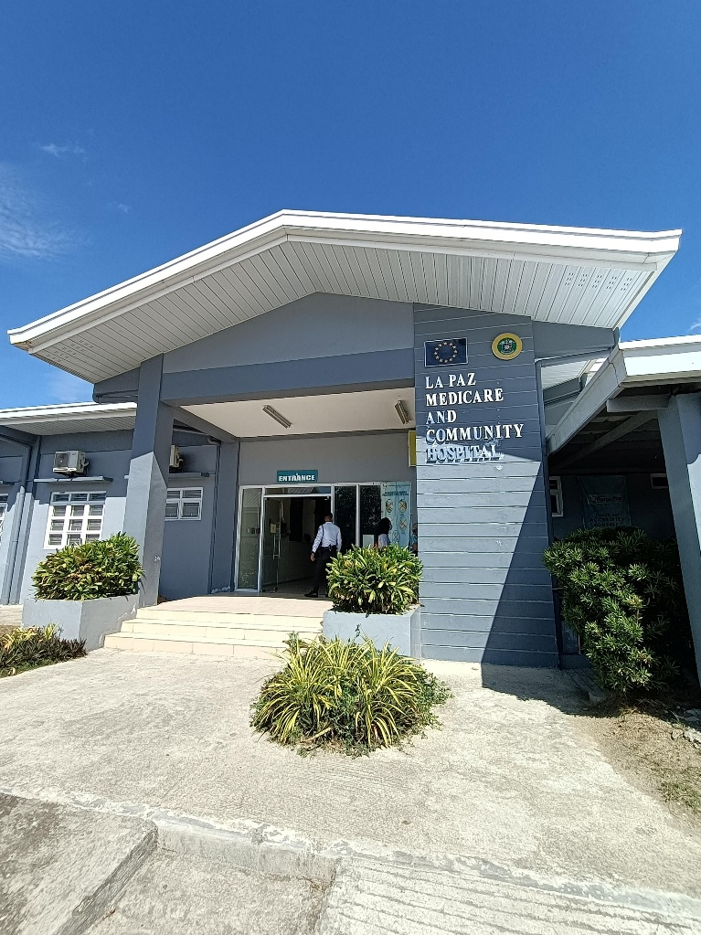

Figure 2: La Paz Medicare and Community Hospital in Nueva Ecija

Our team visited two healthcare facilities before arriving at Cuyapo Infirmary, which is the main focus of our project under Wireless Access for Health (WAH). The one of the two facilities we visited were La Paz Medicare and Community Hospital.

At Cuyapo, we had the opportunity to closely observe the workplace, understand the workflow, and engage directly with staff to learn about their needs and perspectives. Visiting as a team allowed us to gather insights, ask follow-up questions, and gain a thorough understanding that will guide the design of the system specifically for Cuyapo Infirmary.

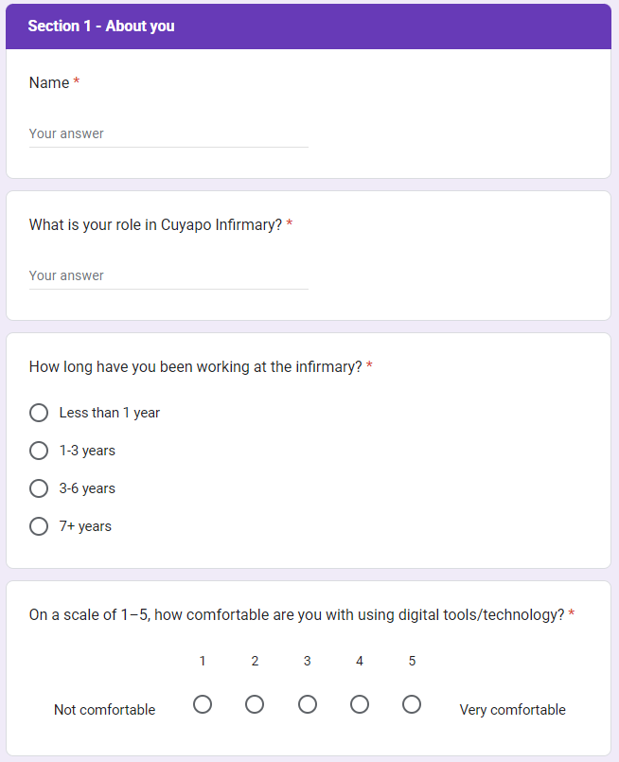

Figure 3: Example of the Google Forms Content

We initially conducted brief onsite interviews with staff at Cuyapo Infirmary and representatives from Wireless Access for Health (WAH). However, given their busy schedules in healthcare, we later sent a more formal set of interview questions through Google Forms to accommodate them. The responses provided valuable insights into their daily routines, challenges, and needs, which now inform the design of a more efficient, user-centered healthcare system.

## **Employee Interview**

We gathered responses from staff at Cuyapo Infirmary and representatives from Wireless Access for Health (WAH) through Google Forms interviews. Their inputs provided valuable insights into daily routines, challenges, and needs, which now guide the design of a more efficient, user-centered healthcare system.

### **Representatives from WAH**

#### **Ms. Nicky Abuso-Balderosa**

Ms. Nicky Abuso-Balderosa, an HR and Training Consultant at Wireless Access for Health (WAH), shared her expertise on training, system adoption, and the long-term vision of WAH4H. Her perspective provided valuable input on how to align the system with user readiness and organizational goals.

1. **What are your main responsibilities when working with partner healthcare centers or hospitals?**

“Preparing the trainers for training delivery.”

1. **From your perspective, what are the most important problems WAH4H aims to solve for small hospitals and infirmaries?**

“Streamline processes and capture valuable data.”

1. **Which hospital processes should WAH4H prioritize to make the most impact?**

Patient registration, Outpatient consultations, PhilHealth e-Claims, Reports

1. **What qualities or characteristics must WAH4H have to be considered successful?**

Cost-effectiveness, User-friendliness for staff, Scalability

1. **In your role’s perspective, what kinds of limitations or risks should we avoid in developing WAH4H?**

“Hard code everything. Make sure it is scalable and adaptable.”

1. **Who do you think will benefit the most from WAH4H, and who should be most engaged during its development?**

Hospital staff: Nurses, Admins, Doctors

1. **What is your long-term vision for WAH4H and its role in improving healthcare delivery in the Philippines?**

“To be the premiere Hospital Information System of choice for public hospitals and infirmaries.”

#### **Ms. Ara Severo**

Ms. Ara Severo, part of the HR team at Wireless Access for Health (WAH), provided her insights into hospital processes, challenges in small healthcare facilities, and the role of WAH4H in improving efficiency. Her perspective emphasized usability, accuracy, and system accessibility for hospitals and infirmaries.

1. **What are your main responsibilities when working with partner healthcare centers or hospitals?**“Assist them on filing claims and provide technical support.”
2. **From your perspective, what are the most important problems WAH4H aims to solve for small hospitals and infirmaries?**  
   “Small hospitals and infirmaries often rely on manual processes, which can cause delays and inefficiencies. WAH4H should address this by improving accuracy and reducing workload.”
3. **Which hospital processes should WAH4H prioritize to make the most impact?**  
   Outpatient consultations and monitoring, Laboratory, PhilHealth e-Claims
4. **What qualities or characteristics must WAH4H have to be considered successful?**  
   Cost-effectiveness, Reliability, and Accuracy
5. **In your role’s perspective, what kinds of limitations or risks should we avoid in developing WAH4H?**  
   “The system should not be hard to use. It must remain user-friendly for staff at all levels.”
6. **Who do you think will benefit the most from WAH4H, and who should be most engaged during its development?**  
   Small hospitals and infirmaries
7. **What is your long-term vision for WAH4H and its role in improving healthcare delivery in the Philippines?**  
   “It will establish standardized, lifelong patient records and make healthcare processes more efficient.”

#### **Mr. Jerimie-Ian Garcia**

Mr. Jerimie-Ian Garcia, a Platform Innovation Partner at Wireless Access for Health (WAH), shared his perspectives on system integration, data accuracy, and the long-term vision of WAH4H. His input emphasized innovation, scalability, and creating a connected healthcare ecosystem.

1. **What are your main responsibilities when working with partner healthcare centers or hospitals?**  
   “WAH EMR reporting.”
2. **From your perspective, what are the most important problems WAH4H aims to solve for small hospitals and infirmaries?**  
   “Data accuracy.”
3. **Which hospital processes should WAH4H prioritize to make the most impact?**  
   PhilHealth e-Claims, Reports, and Logs
4. **What qualities or characteristics must WAH4H have to be considered successful?**  
   Cost-effectiveness, User-friendliness for staff, Scalability
5. **In your role’s perspective, what kinds of limitations or risks should we avoid in developing WAH4H?**  
   “Incompatibility with existing systems, poor scalability, and poor integration.”
6. **Who do you think will benefit the most from WAH4H, and who should be most engaged during its development?**  
   Patients and clinicians who will use the system
7. **What is your long-term vision for WAH4H and its role in improving healthcare delivery in the Philippines?**“WAH aims to create a connected, data-driven healthcare system that improves outcomes and efficiency nationwide.”

### **Staff from Cuyapo Infirmary**

#### **Ms. Benditha B. Babac**

Ma’am Benditha, an Administrative Officer at Cuyapo Infirmary with 3–6 years of experience, provided valuable insights into the facility’s workflow and challenges. Her extensive experience helped us gain a deeper understanding of the needs and requirements for the new system.

1. **Can you describe a typical day in your work related to patient care or records?**  
   “I make sure all patient records are updated and accurate.”
2. **What tasks do you usually handle?**  
   Billing/insurance (PhilHealth, etc.), Reporting, Patient Records Management
3. **Who do you interact with most often when handling patient records?**  
   Administrative staff
4. **Which of the following are your biggest frustrations?**  
   Delays from manual processes, Difficulty retrieving records, Errors in manual encoding
5. **Can you share a recent situation where the current process or system made your work harder?**  
   “We encountered a situation where our current process caused delays in retrieving patient data during emergencies.”
6. **What matters most to you when working with patient information?**  
   Speed and efficiency
7. **If you could change one thing about how patient data is managed today, what would it be?**  
   “I would advocate for the full implementation of a digital system to minimize manual tasks.”
8. **What’s the most important outcome you’d like to see from a new system?**  
   Improved efficiency and reduced manual workload
9. **On a scale of 1–5, how urgent is it to improve the current process/system?**  
   5 (Very urgent)
10. **How would you describe your ideal experience in handling patient records?**  
    “I would like to access patient information quickly and accurately without delays.”
11. **What would make your work life significantly better in the next 1–2 years?**  
    Having a digital platform that reduces manual work and ensures smooth operations
12. **From your perspective, what role should technology play in improving community healthcare?**  
    “Technology can improve how patient data is stored, retrieved, and used to provide better healthcare services.”
13. **Do you have any additional thoughts, suggestions, or stories you’d like to share?**  
    “I’d like to share that small improvements in record-keeping already make a big difference. A proper system will definitely help us and the patients.”

#### **Ms. Madel Lozano**

Ms. Madel Lozano, a Nurse at Cuyapo Infirmary with 1–3 years of experience, shared her perspectives on patient care and record handling. Her insights provided a closer look at the challenges faced by frontline staff and highlighted the importance of accessible, secure, and efficient systems in supporting healthcare delivery.

1. **Can you describe a typical day in your work related to patient care or records?**  
   “Since July 1, 2025, we had an increased number of outpatients. My day usually involves handling patient consultations, assisting doctors, and ensuring that medical records are properly updated.”
2. **What tasks do you usually handle?**  
   Patient registration, Recording consultations, Preparing records for doctors and staff
3. **Who do you interact with most often when handling patient records?**  
   Record section staff
4. **Which of the following are your biggest frustrations?**  
   Delays from manual processes, Difficulty retrieving records, Errors in manual encoding
5. **Can you share a recent situation where the current process or system made your work harder?**  
   “Since the first step is the creation or retrieval of old records, delays happen often and make it difficult to proceed with patient care.”
6. **What matters most to you when working with patient information?**  
   Security and privacy
7. **If you could change one thing about how patient data is managed today, what would it be?**  
   “Systematic management of records to avoid confusion and duplication.”
8. **What’s the most important outcome you’d like to see from a new system?**  
   Easy to use and accessible anytime
9. **On a scale of 1–5, how urgent is it to improve the current process/system?**  
   5 (Very urgent)
10. **How would you describe your ideal experience in handling patient records?**  
    “Accurate, efficient, and secure.”
11. **What would make your work life significantly better in the next 1–2 years?**  
    “Several improvements in processes and tools that will help reduce delays and workload.”
12. **From your perspective, what role should technology play in improving community healthcare?**  
    “Technology should play a role in improving communication, access, and efficiency in healthcare delivery.”
13. **Do you have any additional thoughts, suggestions, or stories you’d like to share?**  
    “Simple and easy-to-use systems are important since not all of us are very familiar with digital tools.”

## **Actual Personas**

**Persona 1: Nicky Abuso-Balderosa (HR and Training Consultant – Wireless Access for Health)**

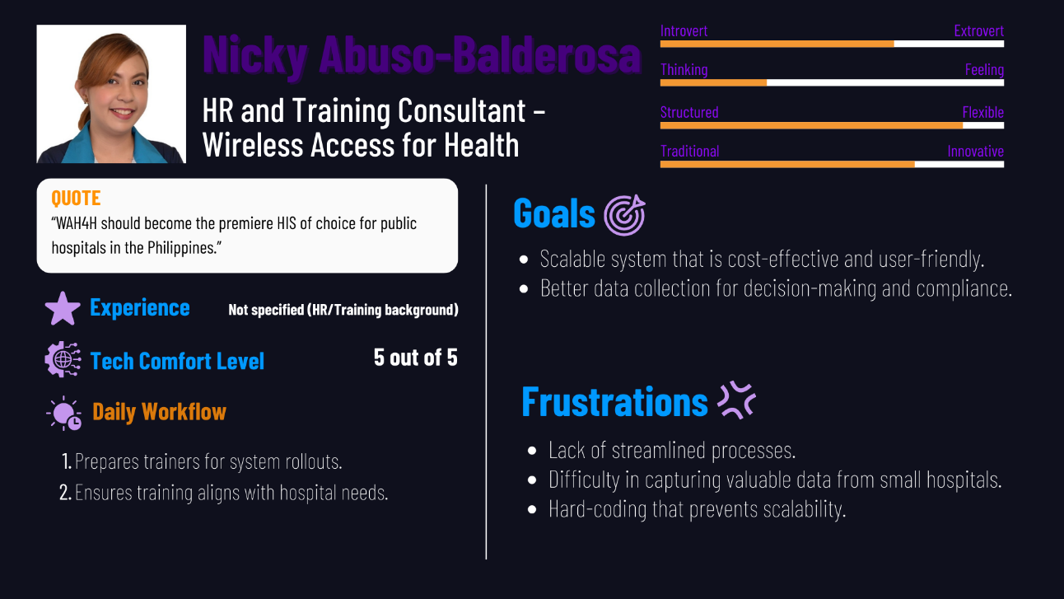

Figure 4: Actual Persona of Nicky Abuso-Balderosa

**Persona 2: Ara Severo (HR – Wireless Access for Health)**

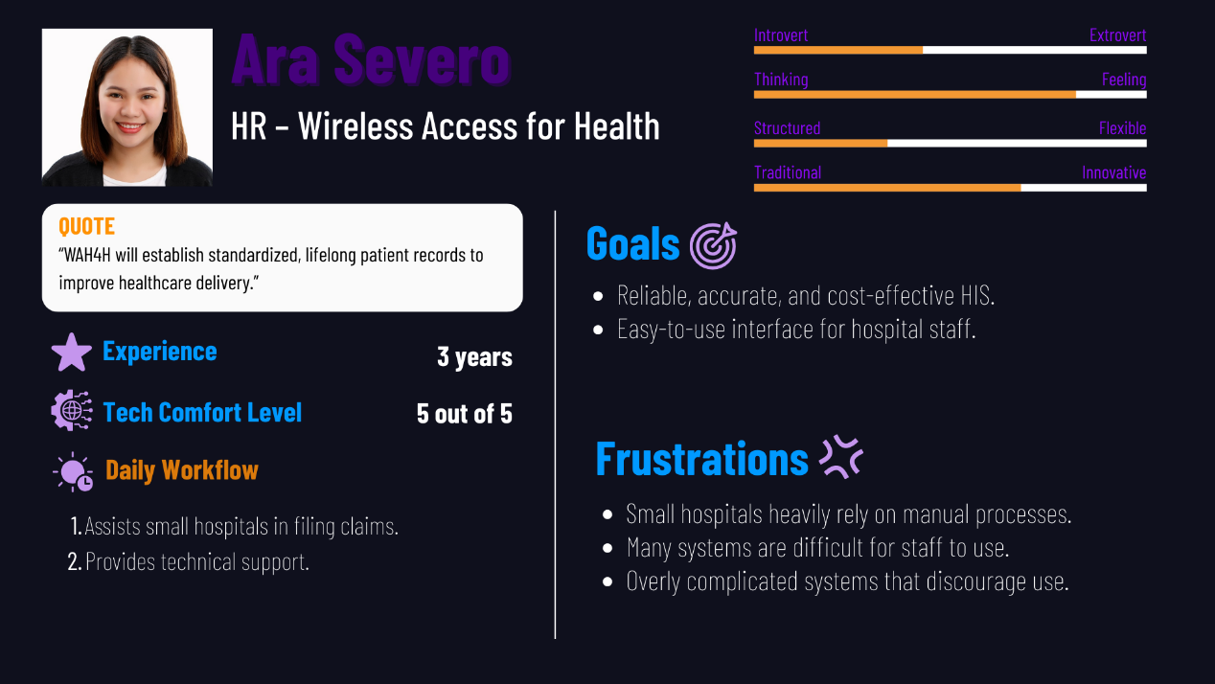

Figure 5: Actual Persona of Ara Severo

**Persona 3: Jerimie-Ian Garcia (Platform Innovation Partner – Wireless Access for Health)**

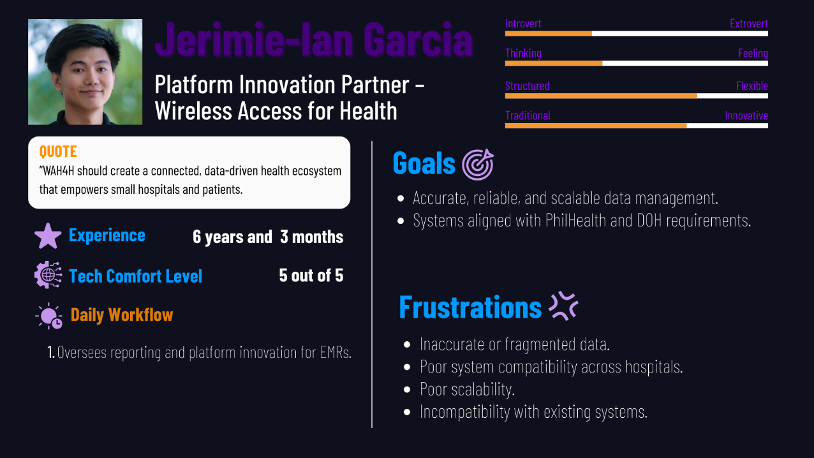

Figure 6: Actual Persona of Jerimie-Ian Garcia

**Persona 4: Benditha D. Babac (Administrative Officer – Cuyapo Infirmary)**

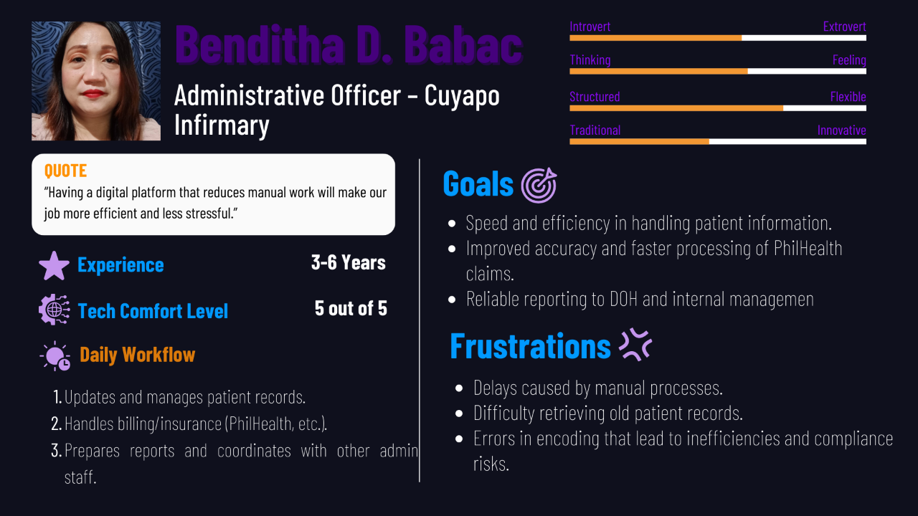

Figure 7: Actual Persona Benditha D. Babac

**Persona 4: Madel Lozano (Nurse – Cuyapo Infirmary)**

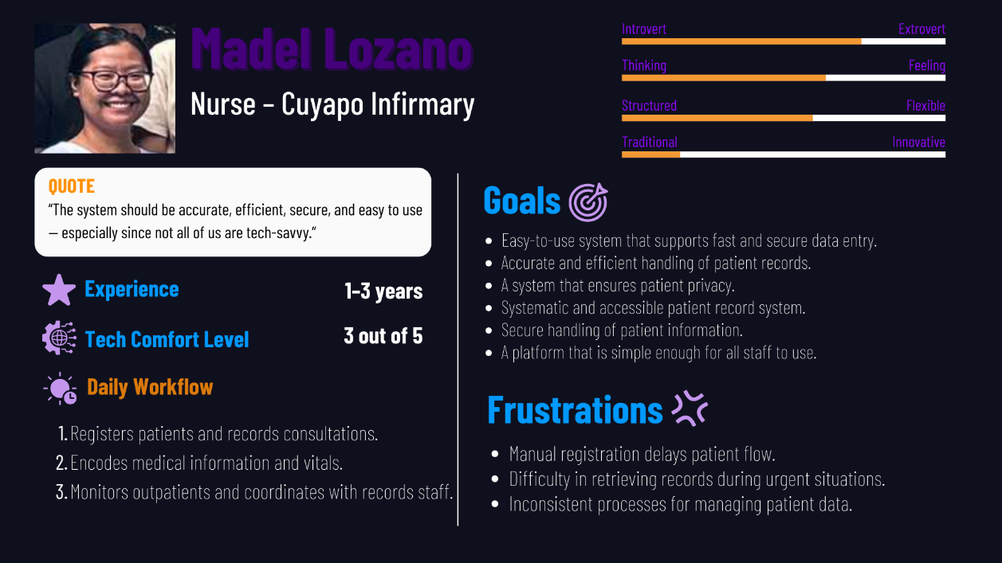

Figure 8: Actual Persona Madel Lozano

## **Theoretical Personas**

**Persona 1: Patrick Navvaro (Co-Owner)**

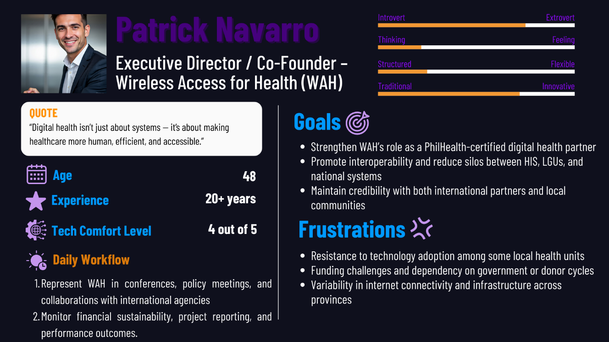

Figure 9: Theoretical Persona of Patrick Navarro

**Persona 2: Jose Manual Gonzales (Records & Admissions Officer)**

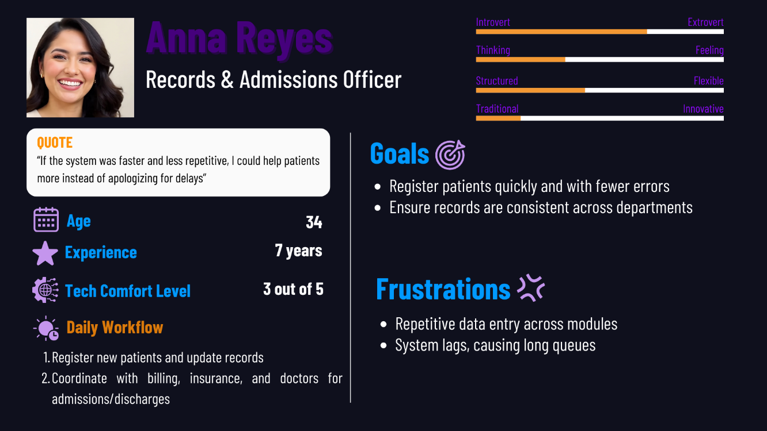

Figure 10: Theoretical Persona of Anna Reyes

**Persona 4: Erica Abella (Staff Nurse – General Ward)**

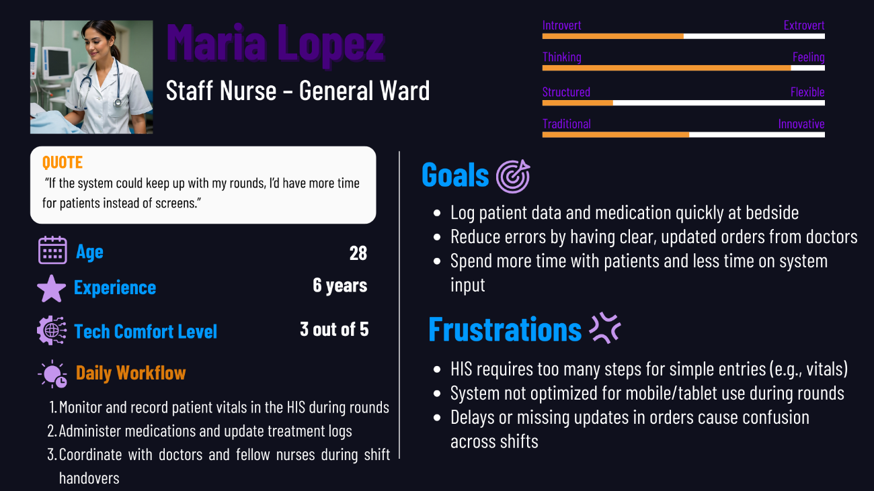

Figure 11: Theoretical Persona of Maria Lopez

**Persona 4: Dr. Miguel Santos (Attending Physician)**

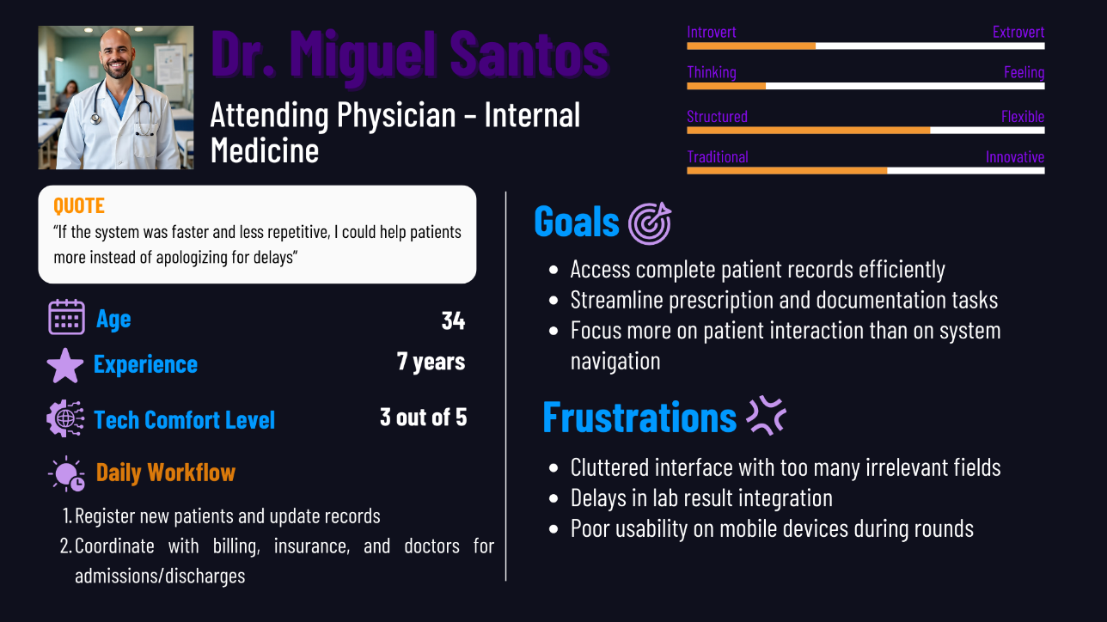

Figure 12: Theoretical Persona of Dr. Miguel Santos

**Persona 5: Erica Abella (Billing & Discharge Officer)**

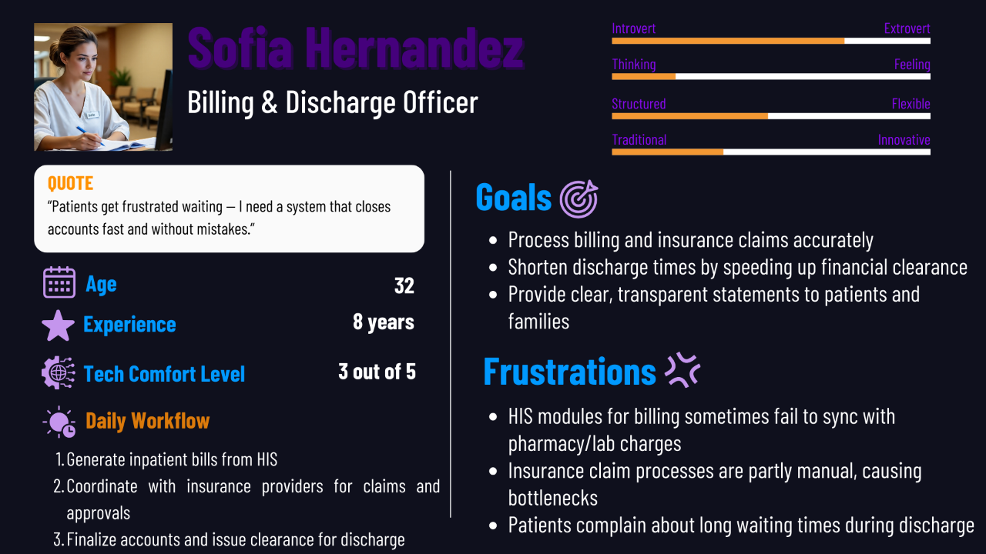

Figure 13: Theoretical Persona of Sofia Hernandez

## **Empathy Map**

**Nicky Abuso-Balderosa (HR and Training Consultant)**

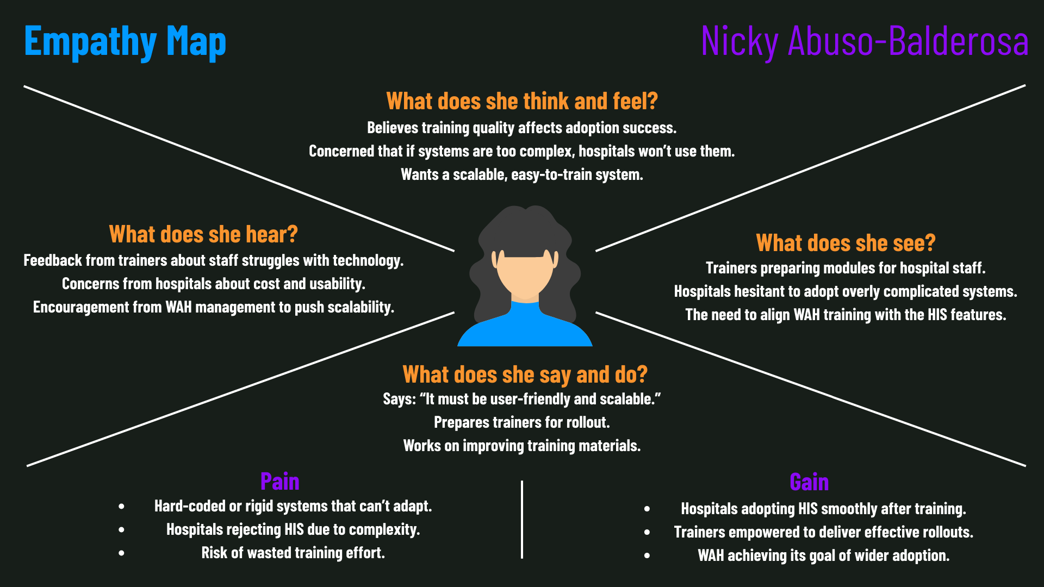

Figure 14: Empathy Map for Nicky Abuso-Balderosa

**Jerimie-Ian Garcia (Platform Innovation Partner)**

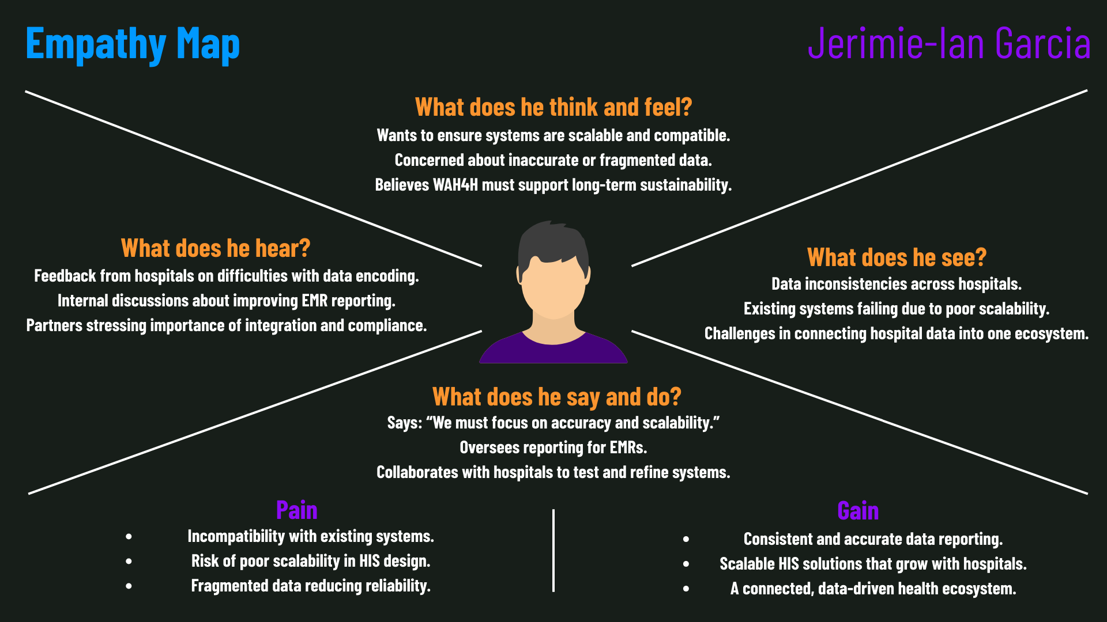

Figure 15: Empathy Map for Jerimie-Ian Garcia

**Ara Severo (WAH - HR)**

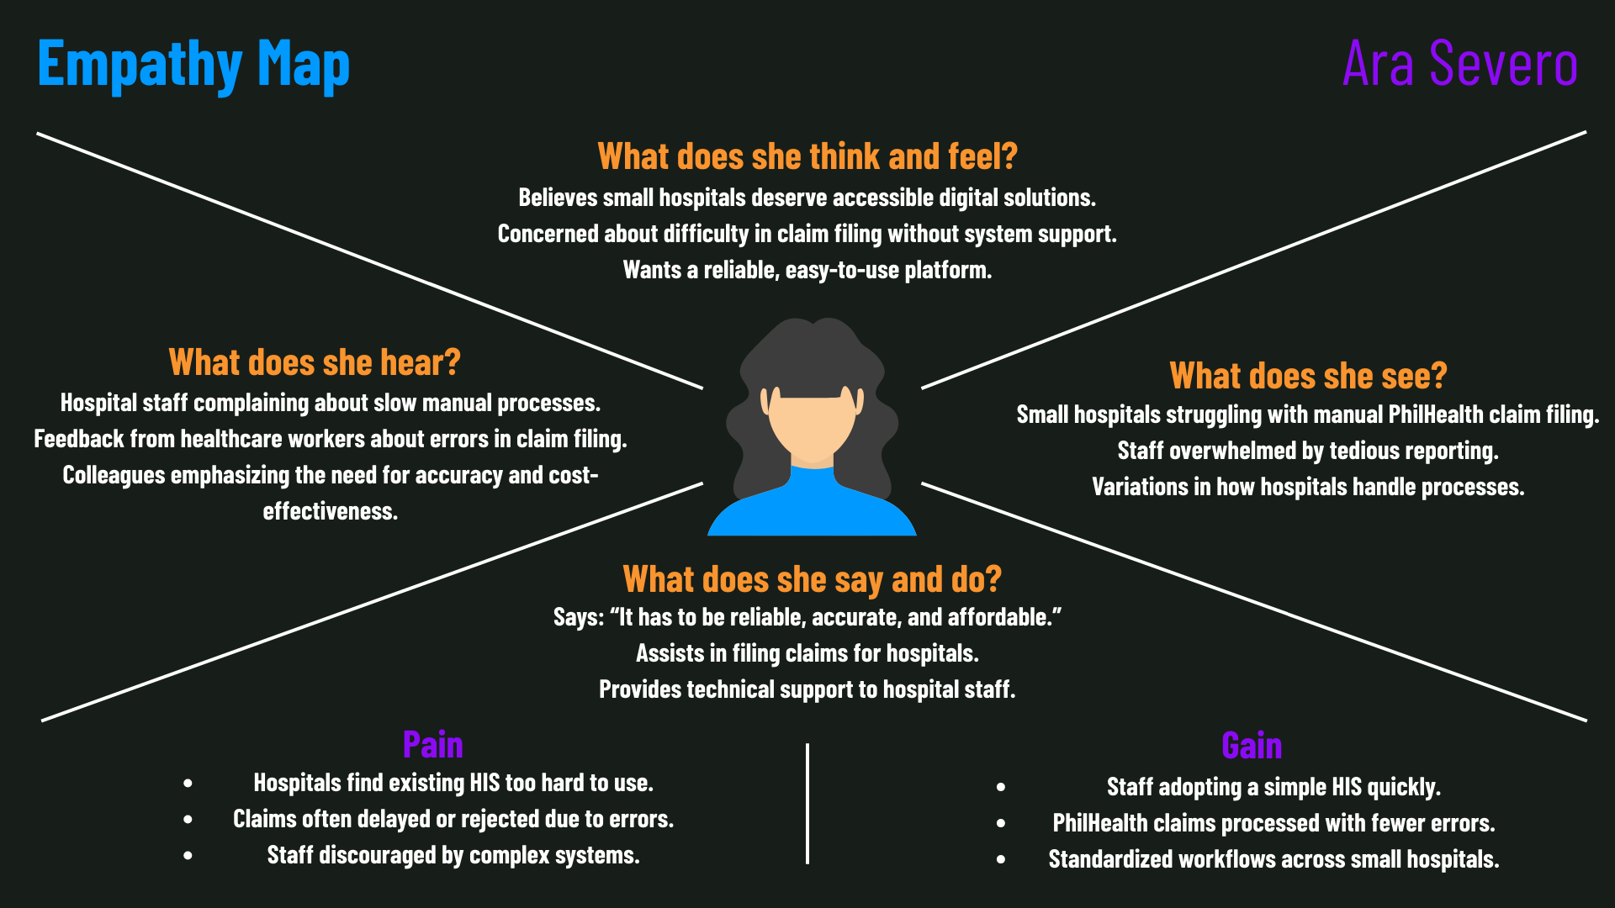

Figure 16: Empathy Map for Ara Severo

**Madel Lozano (Nurse – Cuyapo Infirmary)**

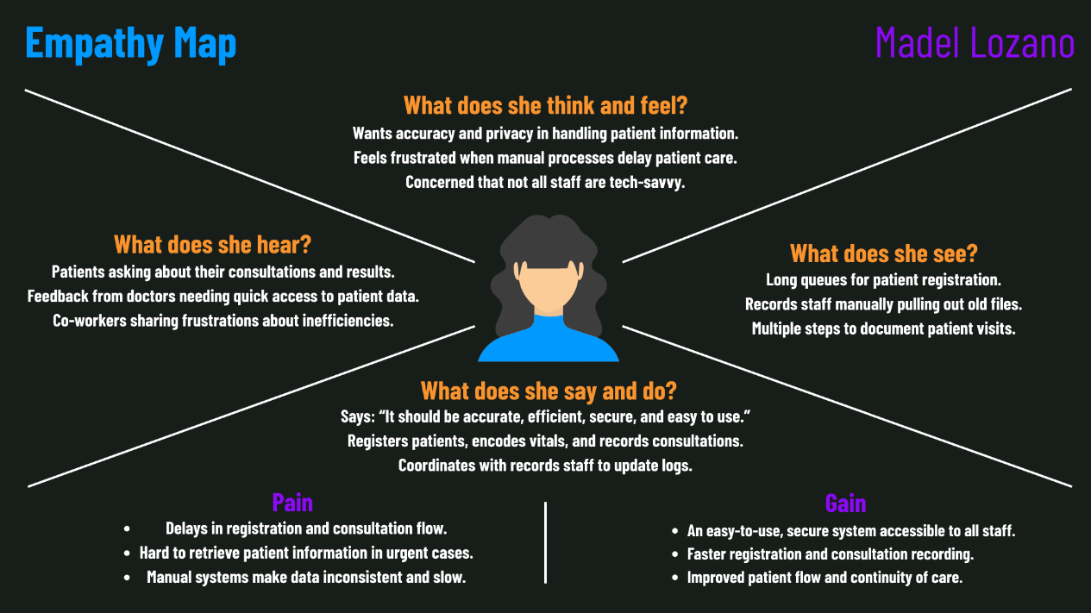

Figure 17: Empathy Map for Madel Lozano

**Benditha D. Babac (Administrative Officer – Cuyapo Infirmary)**

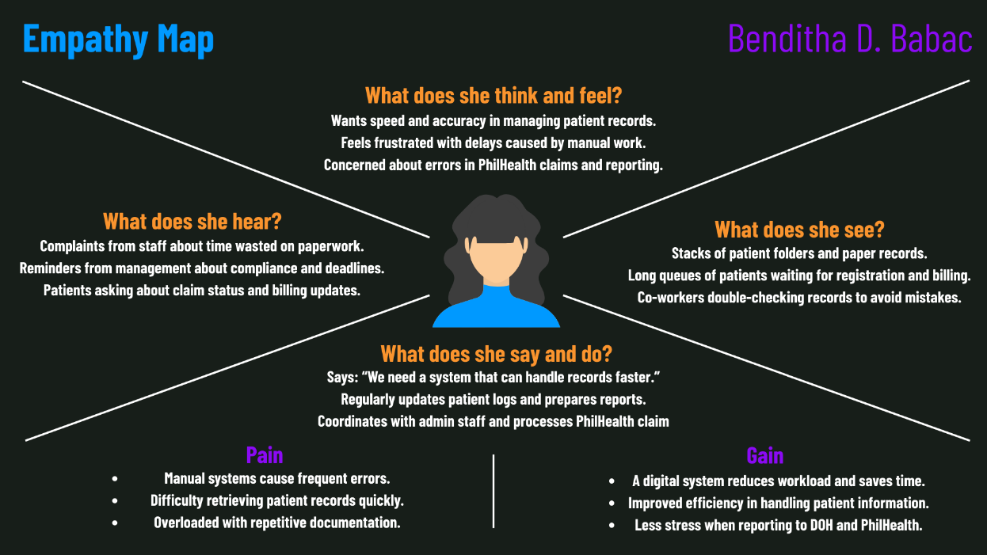

Figure 18: Empathy Map for Benditha Babac

## **Pain-Gain Analysis Summary**

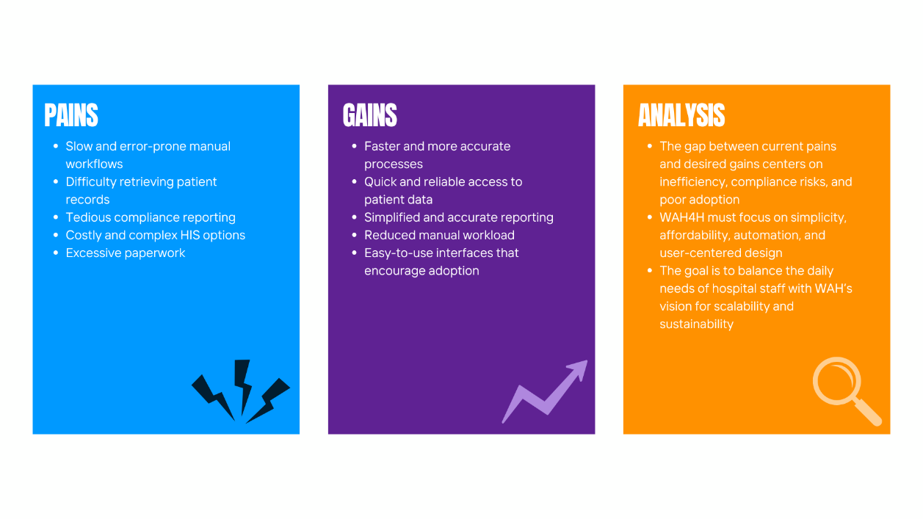

Figure 19: Pain-Gain Analysis Summary

# Stage 2: Define

In the Define stage, we shift from gathering insights to clarifying the core challenges faced by our stakeholders. Building on what we learned during the Empathize phase, we examined the pain points of healthcare staff, administrators, and patients, then grouped them into key categories. This step helped us move from scattered issues to a structured view of the problems that matter most.

Through clustering, we identified recurring themes in patient records, staff workload, and billing processes. These clusters provided the foundation for developing problem statements and “How Might We” questions, ensuring that our focus remains aligned with the real needs of WAH and Cuyapo Infirmary.

## **Clustered Problems**

After analyzing the results of the interviews, empathy maps, and pain-gain analysis, the team categorized the identified issues into three major clusters: Patient Records & Data Management, Staff Workload, and Billing & Payments. These clusters represent the most pressing challenges faced by Cuyapo Infirmary staff and partner stakeholders under Wireless Access for Health (WAH).

### **Patient Records & Data Management**

* Delays in retrieving patient records during consultations or emergencies.
* Errors and inconsistencies caused by manual data entry.
* Risk of misplaced or lost paper records.
* Difficulty updating patient records across multiple departments.
* Lack of centralized access for doctors, nurses, and administrative staff.
* Duplication of records due to uncoordinated manual systems.
* Insufficient security measures for protecting sensitive patient information.
* Inability to generate quick reports for compliance and audits.

### **Staff Workload**

* Excessive paperwork required from healthcare staff (registration, billing, reports).
* Long queues caused by slow, manual processes.
* Repetitive documentation tasks, reducing time for patient care.
* Staff struggling to balance administrative tasks with medical duties.
* Over-reliance on a few employees for key processes, leading to burnout.
* Time wasted searching for files or forms.
* Limited training and familiarity with digital tools.
* Stress caused by inefficiencies, affecting work-life balance.

### **Billing & Payments**

* Limited payment methods available for patients.
* Lack of transparency in billing processes (unclear or delayed bills).
* Errors in computing PhilHealth claims or patient balances.
* Manual tracking of payments leading to inaccuracies.
* Delays in processing refunds or adjustments.
* Difficulty handling patients with installment or debt-based payment terms.
* No automated system for generating receipts and invoices.
* Challenges in consolidating billing data with patient records.

## **Problem Statement**

1. Manual and paper-based records cause delays, errors, and inconsistencies.
2. Lack of a centralized database makes access and updates inefficient.
3. Records are often duplicated, misplaced, or insecure.
4. Generating reports for compliance and audits is slow and difficult.
5. Excessive paperwork and repetitive tasks reduce time for patient care.
6. Manual processes create long queues and inefficiencies.
7. Staff face stress and burnout due to workload and limited digital skills.
8. Billing is manual, error-prone, and lacks transparency.
9. Limited payment options inconvenience patients.
10. PhilHealth claims and balances are often inaccurate.
11. Consolidating billing data with patient records is inefficient.

## **How-Might-We**

1. How might we create a centralized and secure patient records system that allows quick access for doctors, nurses, and administrative staff?
2. How might we minimize errors and duplication in patient data entry?
3. How might we reduce paperwork and streamline documentation tasks for healthcare staff?
4. How might we shorten patient queues and improve the flow of hospital processes?
5. How might we simplify the billing process to ensure accuracy and transparency for patients?
6. How might we integrate PhilHealth e-claims and automate receipts to reduce manual workload?
7. How might we ensure billing data is seamlessly integrated with patient records?

## **Conclusion**

After analyzing and clustering the issues and challenges faced by our clients, employees, and customers, we have formulated a problem statement that identifies the root problems they are

encountering. From there, we have developed "How Might We" statements that concentrate on potential solutions to these problems. Prior to this stage, our understanding of our client's system problems was quite limited, but we went deeper into different stages of the design thinking process. It gives us a better understanding and clear vision of what our client needs and what area we should focus on.

# Stage 3 – IDEATE

In the third phase of the Design Thinking process, Ideate, we worked closely as a team to brainstorm and explore creative solutions. We made sure to create an open and supportive space where everyone could contribute ideas to addressing the challenges we discovered earlier. At this stage, our focus was on reframing problems in fresh ways and defining clear objectives that consider the needs of our clients, our team, and their customers with the shared goal of driving the growth of Speed Up Garage.

## **Brainstorming Session**

In this session, we shared our opinions and suggestions to broaden our ideas. We created an open environment where everyone could freely express their thoughts, using Microsoft Teams and a FigJam board from Figma to facilitate brainstorming. To ease into the session, we started with casual conversations before listing our ideas on the board and encouraging out-of-the-box thinking. The team then voted on the concepts with the most potential or best alignment with our problem statement, helping us identify the key features to focus on for our project.

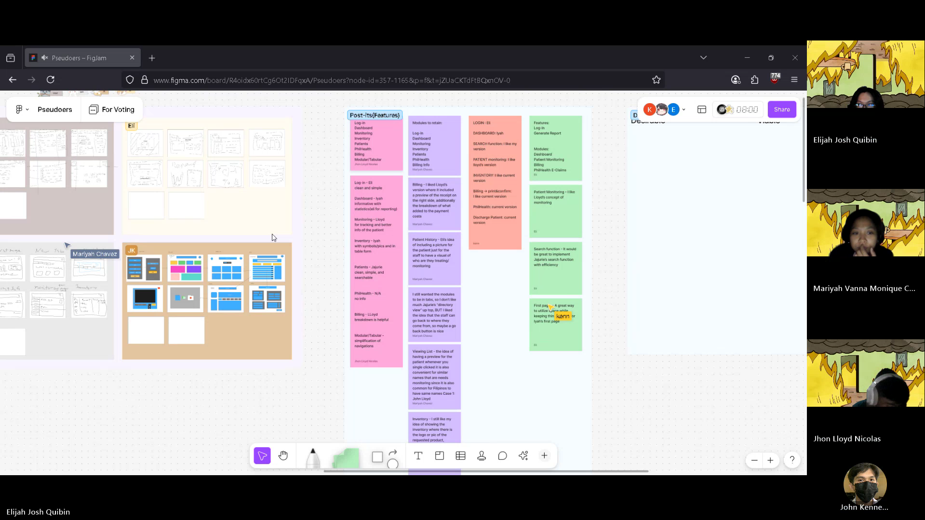

Figure 20: Pseudoers Brainstorming Session

## **Crazy 8’s**

In this session, we used Figma’s Crazy 8’s feature to sketch ideas quickly, starting with a 5-minute round and then extending by another 7 minutes to refine and expand our concepts. Each of us created simple visual representations of potential solutions across the eight sections. This iterative process allowed us to capture missing features, explore new directions, and build on one another’s ideas. We then shared and discussed the most promising sketches, which guided us toward more innovative solutions.

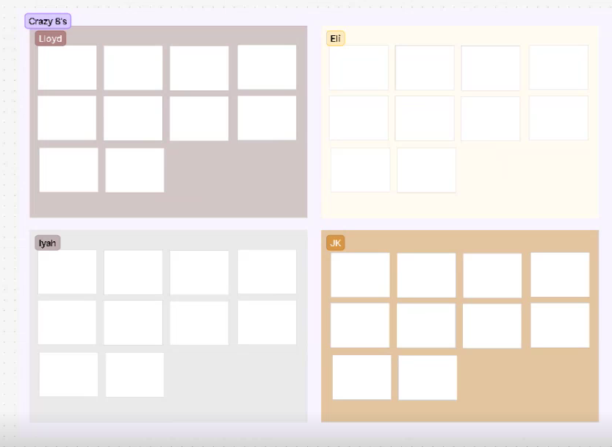

Figure 21: Figma Platform Screenshot

### **Jhon Lloyd Nicolas (Team Leader)**

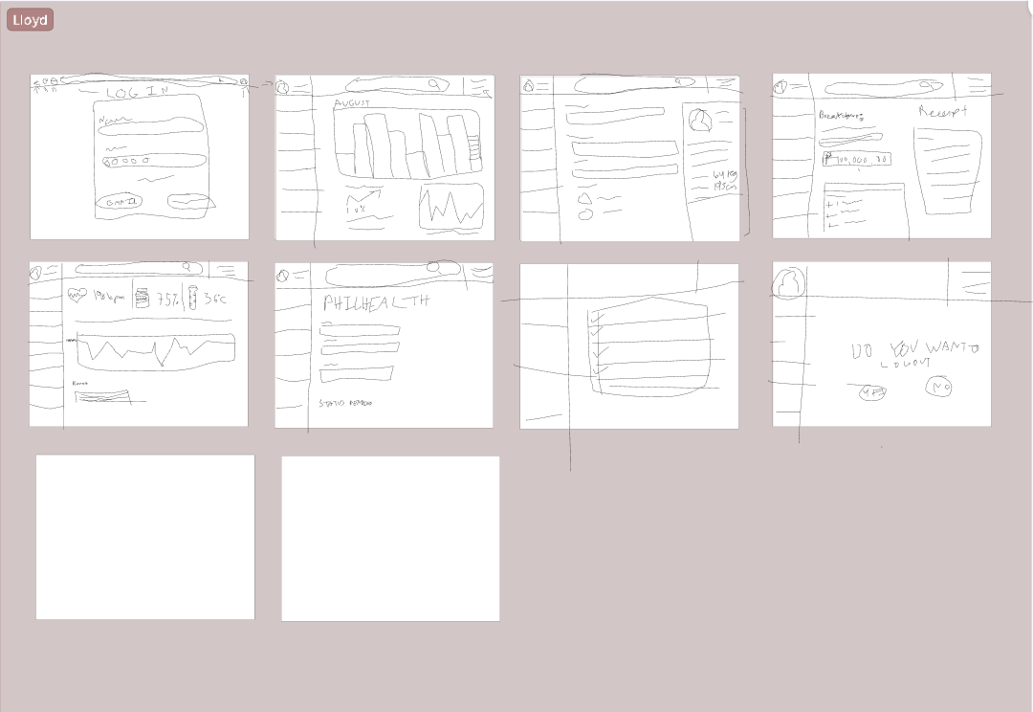

Figure 22: Jhon Lloyd Nicolas' Crazy 8

### **Elijah Josh Quibin (Back-end Developer)**

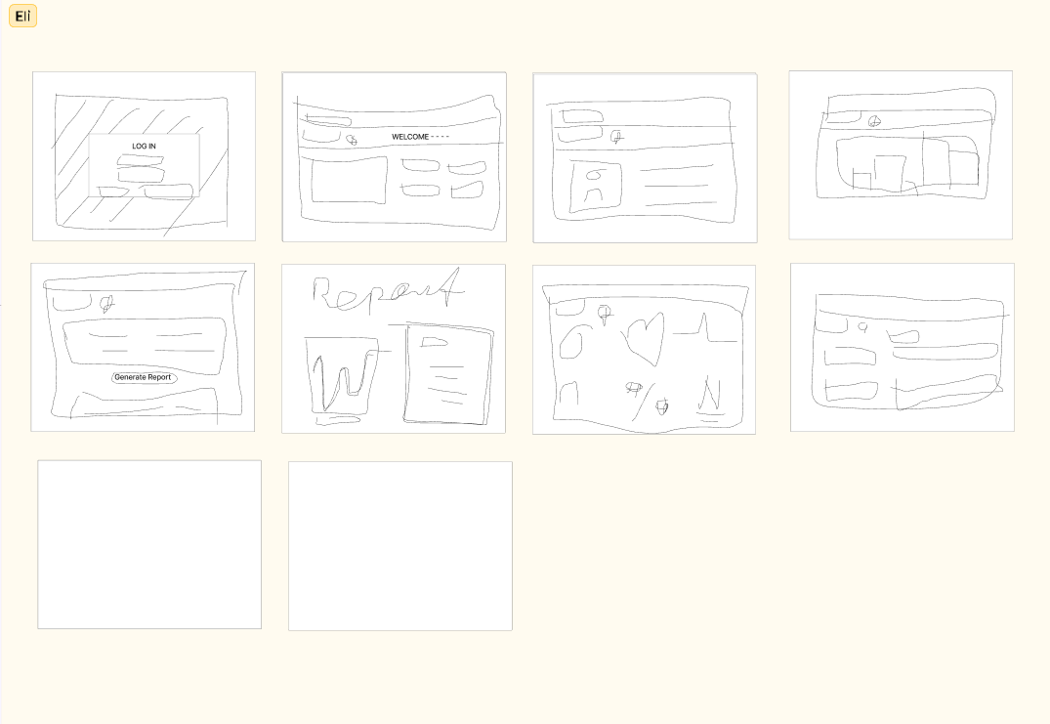

Figure 23: Elijah Josh Quibin's Crazy 8

### **Mariyah Vanna Monique Chavez (Project Manager)**

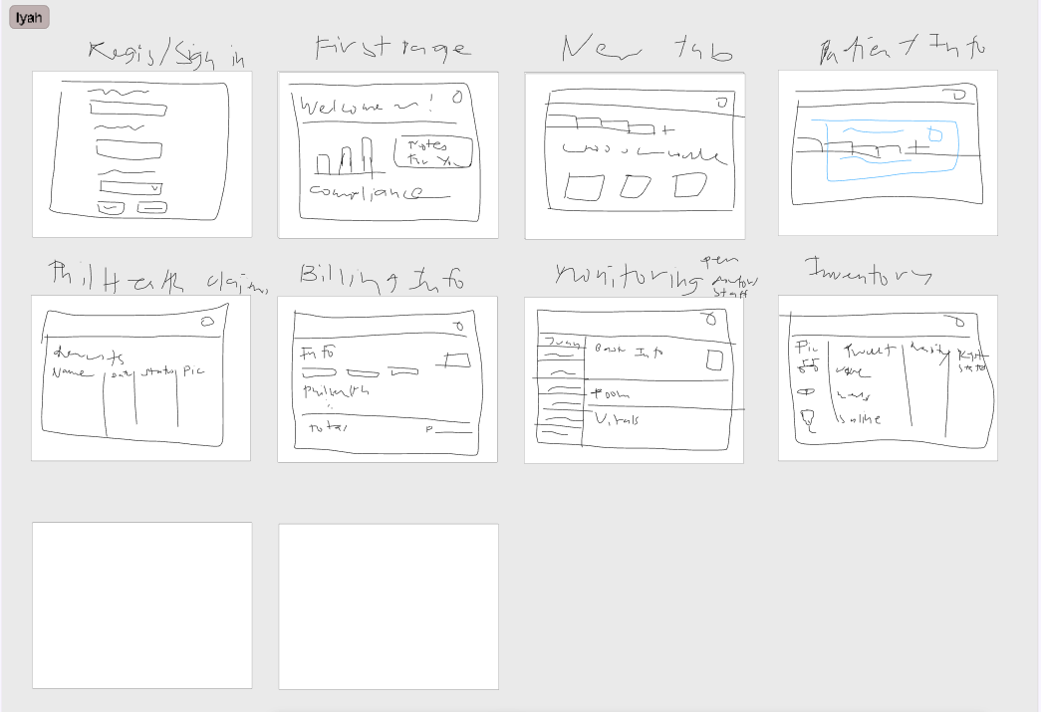

Figure 24: Mariyah Vanna Monique Chavez's Crazy 8

### **John Kenneth Jajurie (Front-end Developer)**

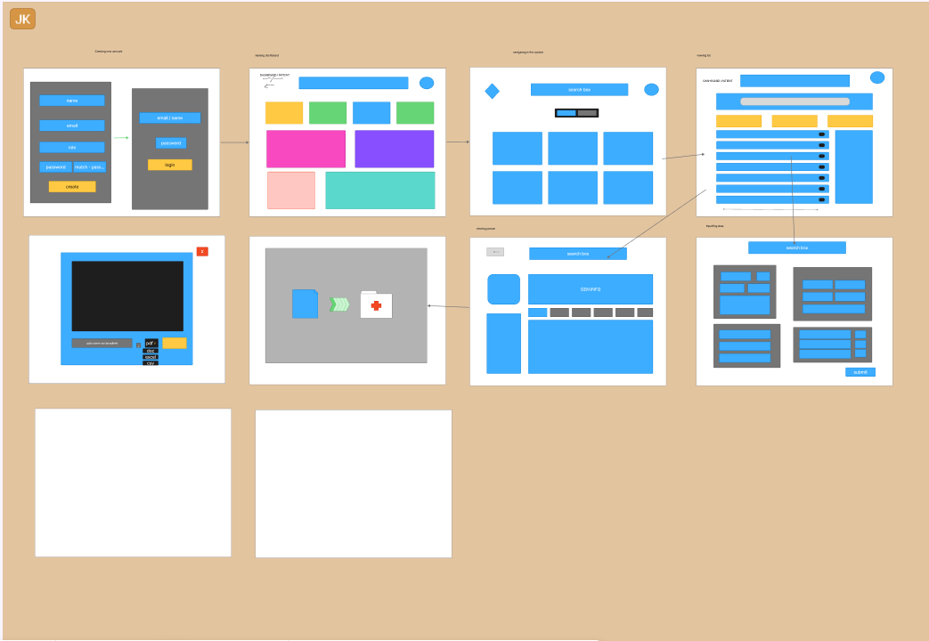

Figure 25: John Kenneth Jajurie's Crazy 8

## **Post It Voting**

After the Crazy 8’s session, we organized our ideas on a FigJam board and voted on the ones we found most promising. This helped us narrow down the features that would be most useful for the system. The selected ideas became the starting point for creating prototypes and preparing for testing in the next steps of the design thinking process.

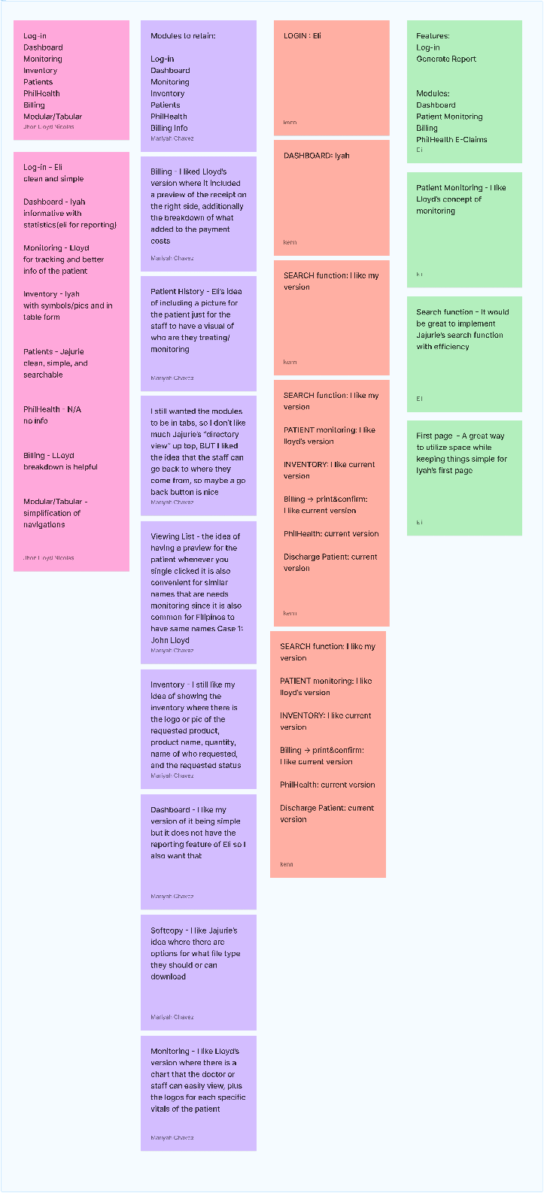

Figure 26: FigJam Board Post It Voting

## **Desirable, Viable, Feasible**

Following our previous session, we used this framework to make sure the selected ideas not only meet user needs and preferences but are also practical for business and achievable with the resources available. For each idea and sketch, we evaluated its alignment with three key aspects: desirability, viability, and feasibility.

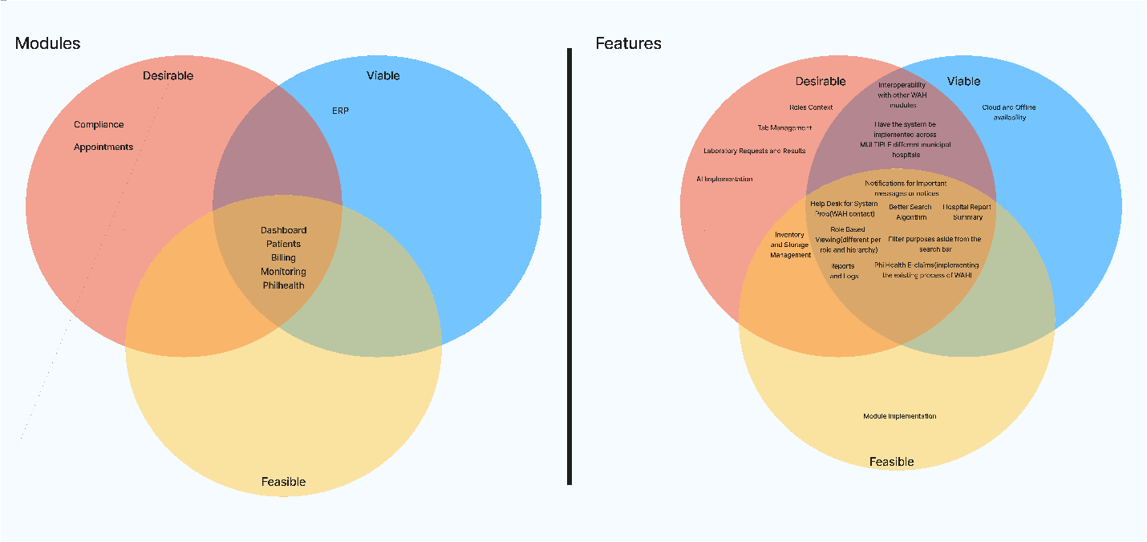

Figure 27: Venn Diagram for Desirable, Viable, Feasible

1. Will this feature make the daily tasks of Cuyapo Infirmary staff easier and improve their experience with the system?
2. Can this idea support WAH’s goals and be sustained in the long run without adding unnecessary costs or complexity?
3. Do we have the tools, skills, and resources to build this feature into the system effectively?
4. Will this idea directly address the challenges we observed in the infirmary’s workflow and bring meaningful improvements?

This assessment helps us focus on ideas that not only fit WAH’s mission of improving healthcare access and efficiency but also respond to the challenges we saw at Cuyapo Infirmary, such as workflow issues and heavy administrative tasks. By looking at desirability, viability, and feasibility, we can narrow down the solutions that make the most sense. This way, we can use our resources wisely and work toward creating practical improvements that truly support both WAH and Cuyapo Infirmary.

# Stage 4: Prototype

In the fourth stage of the Design Thinking process, we focus on prototyping. Each prototype is created with a specific audience in mind and designed to address their challenges. To test these ideas, we build mock-ups or near-functional models and gather feedback from users and stakeholders to see how well they work in practice.

We also use storyboards to visualize how clients, employees, and customers might interact with our solutions, helping us refine designs to fit real-world scenarios. From there, we develop a framework that balances desirability, viability, and feasibility, which guides the creation of our prototypes. For the mock-up design, we collaborate closely with clients, incorporating their preferences on concepts, colors, and design elements to ensure the result matches their vision.

This process bridges the gap between ideas and implementation, allowing us to spot challenges early and refine solutions before moving into full development.

## **Story Boards**

A storyboard illustrates our collaboration with clients and their teams, giving us a clearer view of how they interact with the solutions we create.

### **Elaine Cruz**

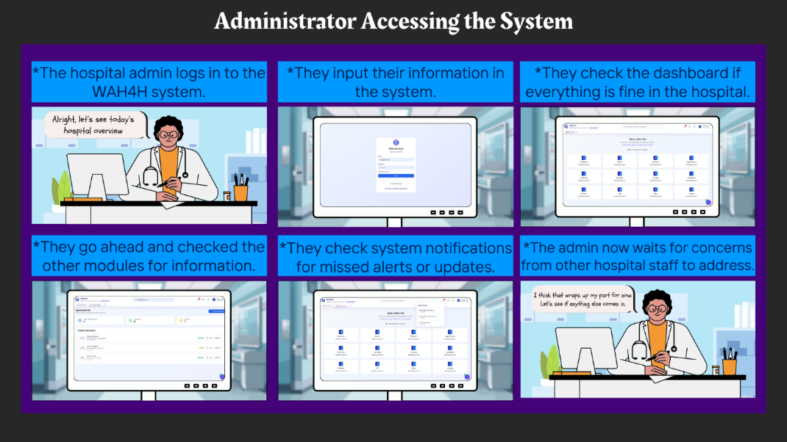

Figure 28: Story Board for Administrator

### **Dr. Antonio Reyes**

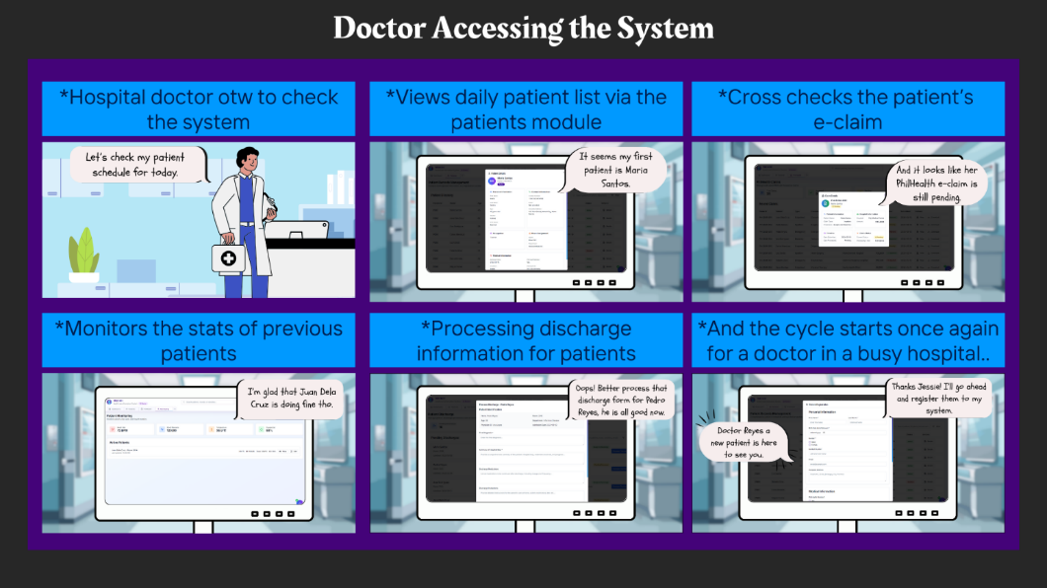

Figure 29: Story Board for Doctor

### **Nurse Maria Lopez**

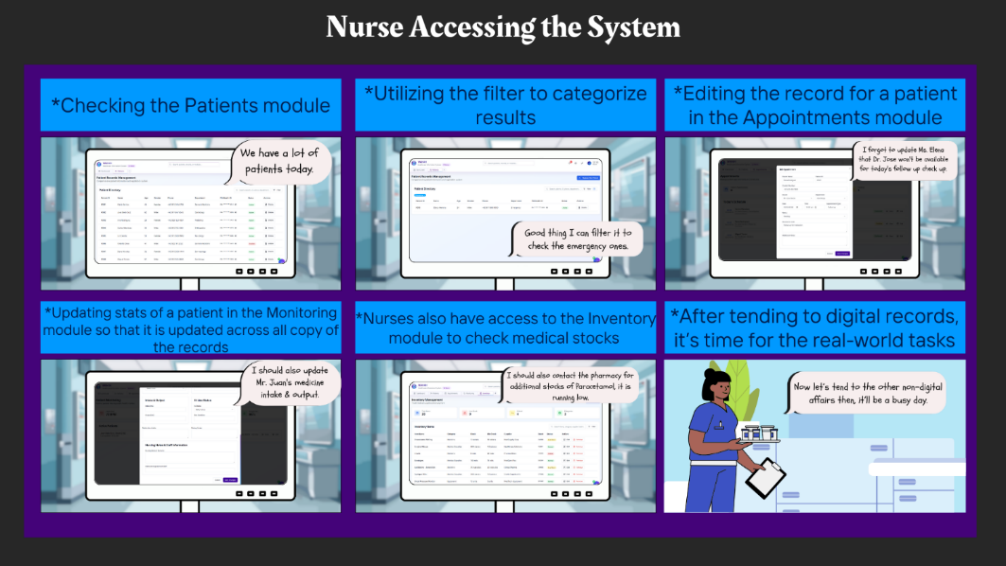

Figure 30: Story Board for Nurse

### **Ana Gutierrez**

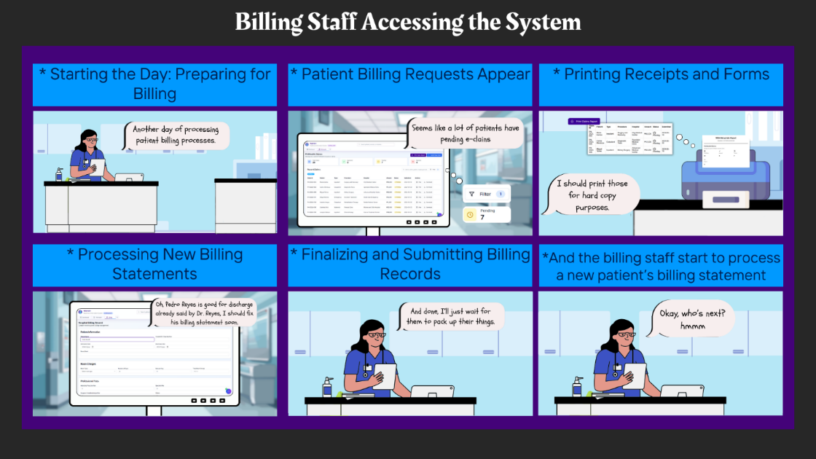

Figure 31: Story Board for Billing Staff

### **Kevin Ramos**

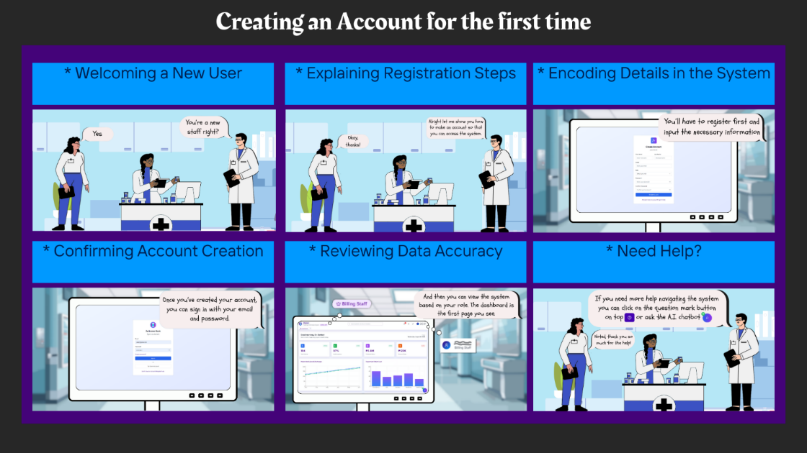

Figure 32: Story Board for Creating an Account for the First Time

### **Erika Santos**

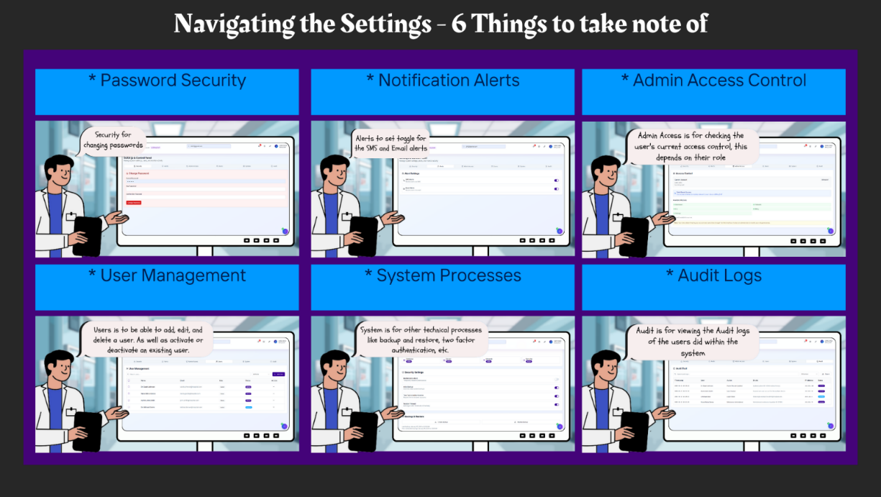

Figure 33: Story Board for Navigating the Settings - 6 Things to Take Note of

**Janelle Cruz**

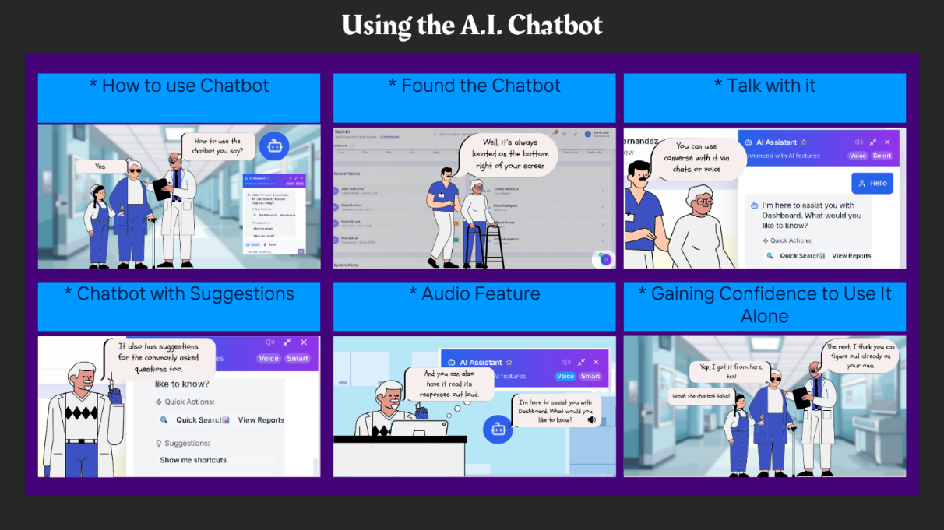

Figure 34: Story Board for Using the A.I. Chatbot

## **Mockup Design**

Mockup designs allow us to translate ideas into something visual and concrete. They give both our team and our clients a clearer picture of how the system might look and feel. Instead of just imagining the features, clients can see them represented and provide feedback early on. This back-and-forth helps us refine details and ensure that the final design is practical, user-friendly, and aligned with client expectations.

### **Login system**

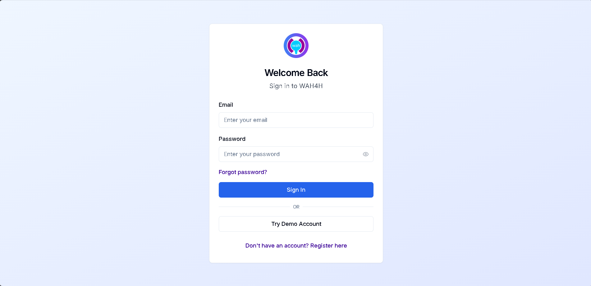

Figure 35: Mockup Design for Login Page

### **Dashboard for Admin**

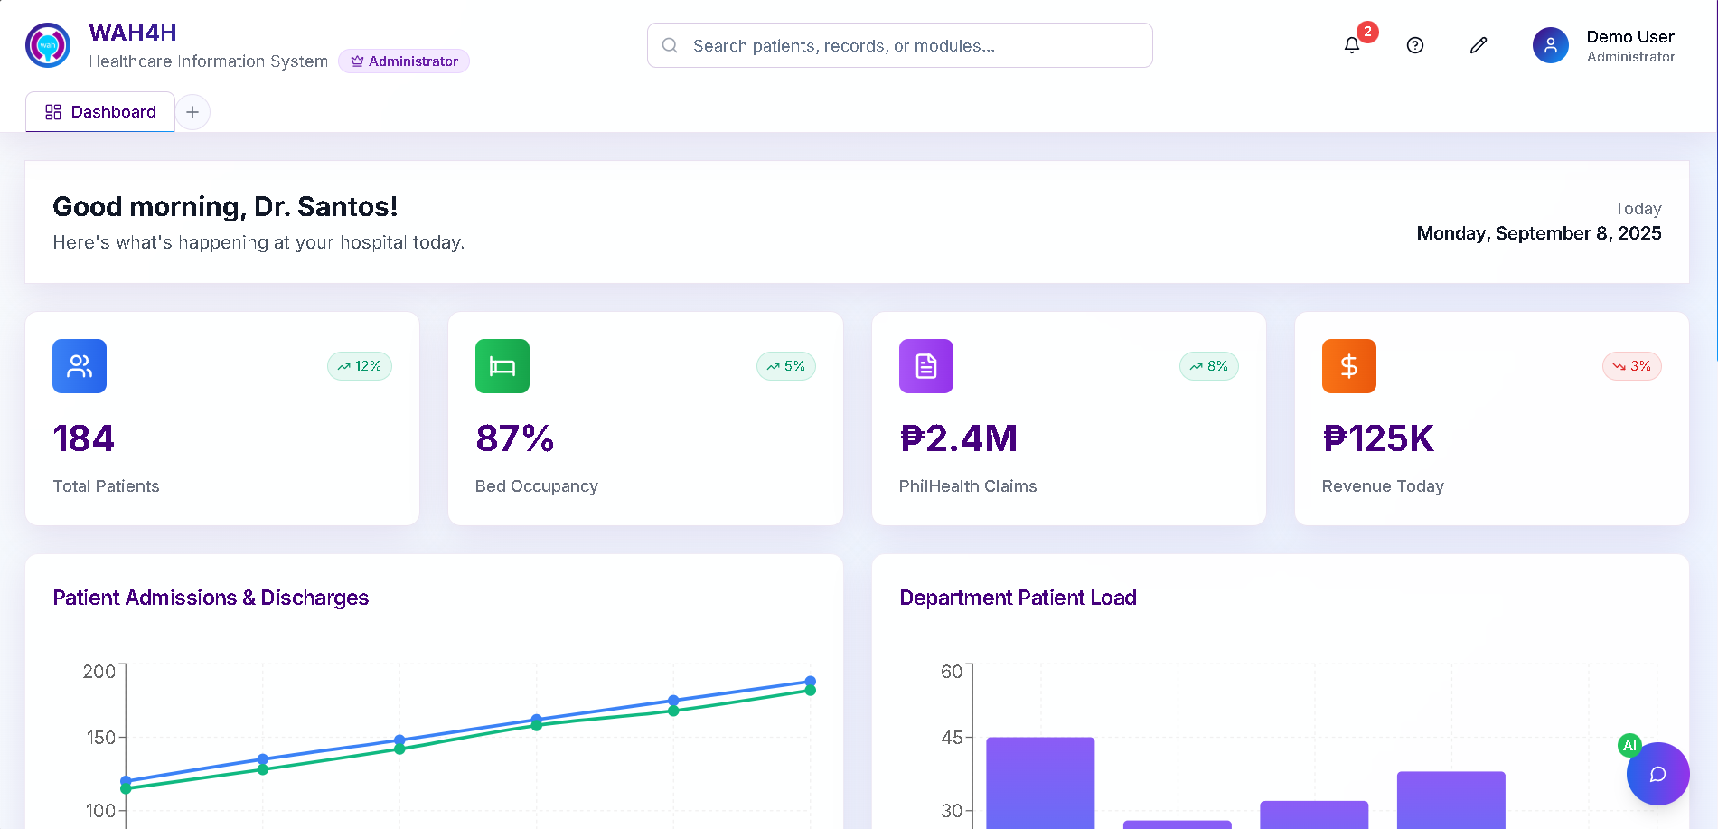

Figure 36:Mockup Design for Admin Dashboard

### **Access Modules – Open New Tab**

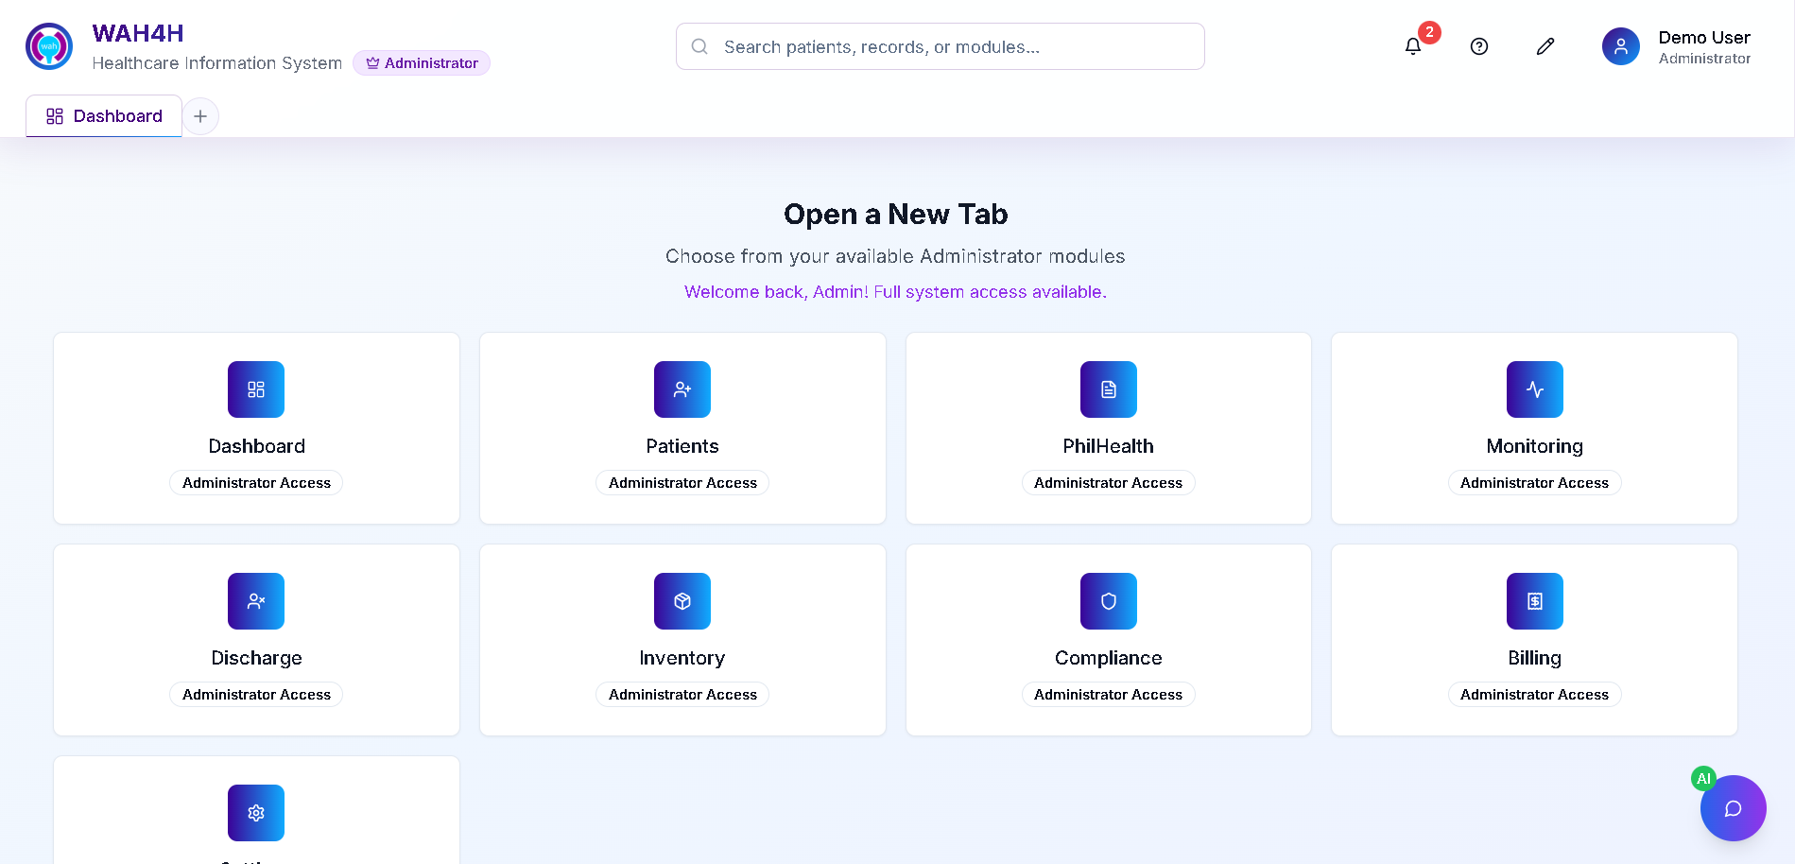

Figure 37: Mockup Design for Opening a New Tab

### **Patient Records Management Module**

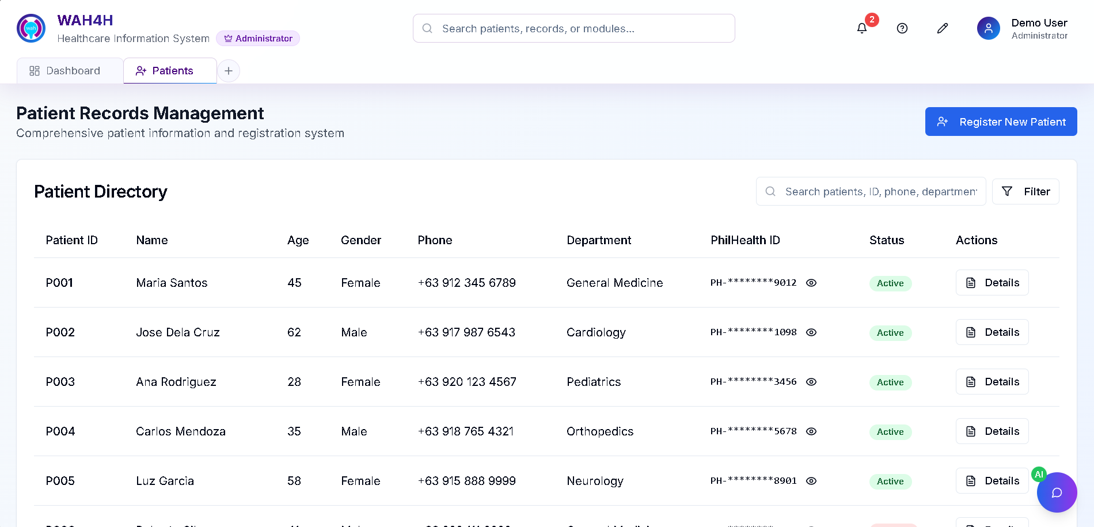

Figure 38: Mockup Design for Patient Records Management

### **Patient Records Management – Patient Registration**

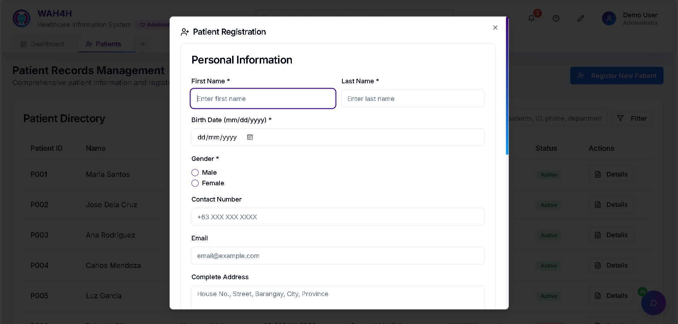

Figure 39: Mockup Design for Patient Registration

### **PhilHealth Claims Module**

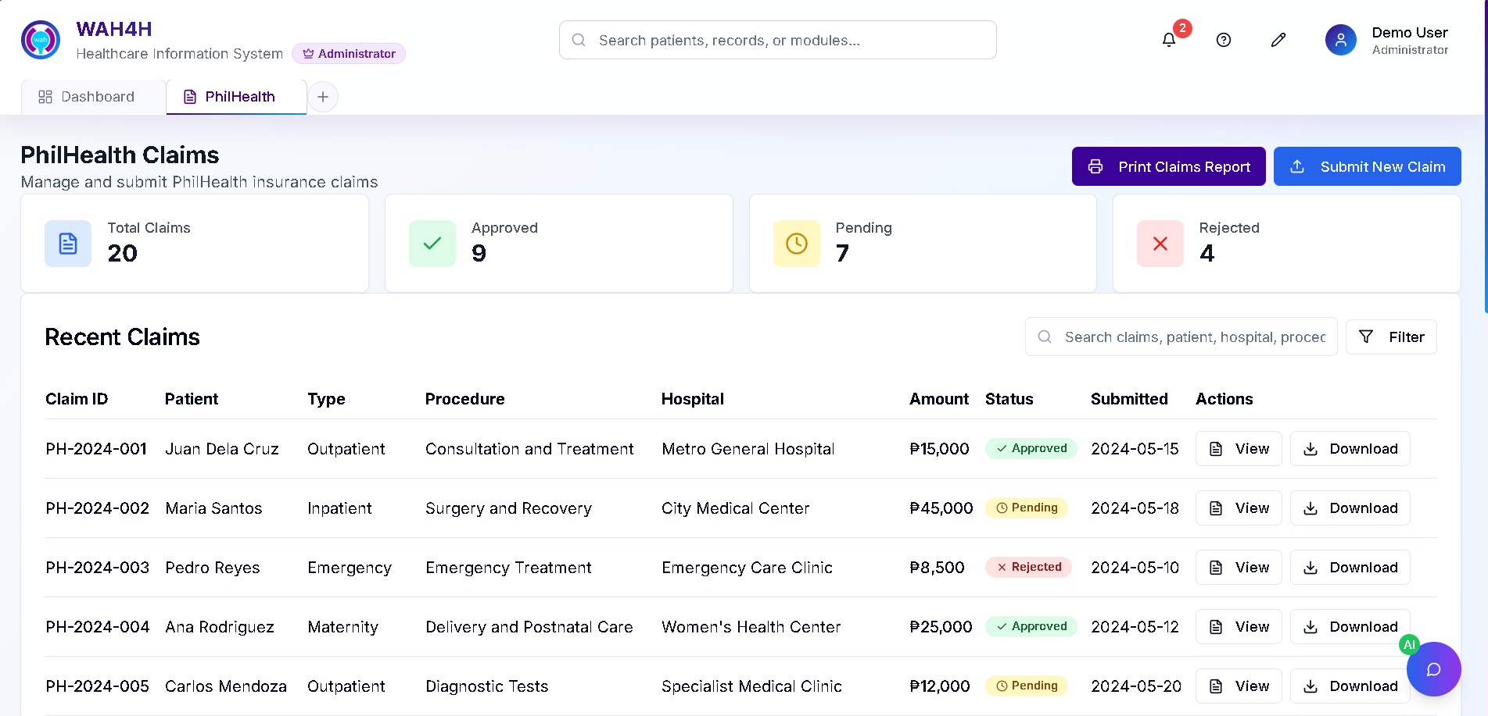

Figure 40: Mockup Design for PhilHealth Claims

### **PhilHealth Claims Module – Print Claims Report**

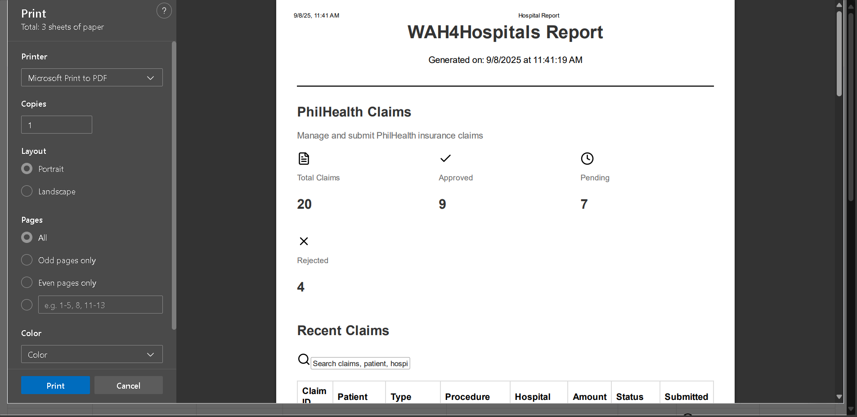

Figure 41: Mockup Design for Print Claims Report

### **Patient Monitoring Module**

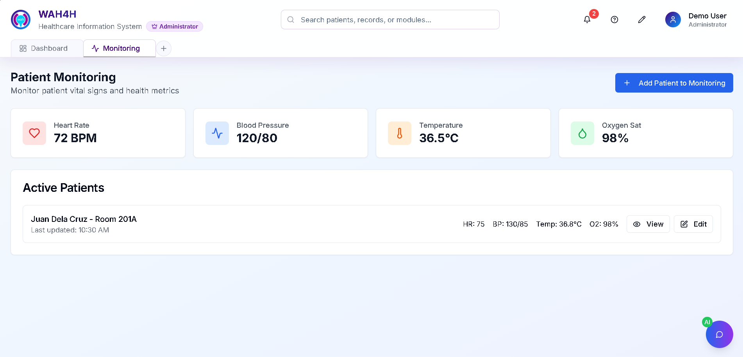

Figure 42: Mockup Design for Patient Monitoring

### **Patient Monitoring – Add Patient Monitoring**

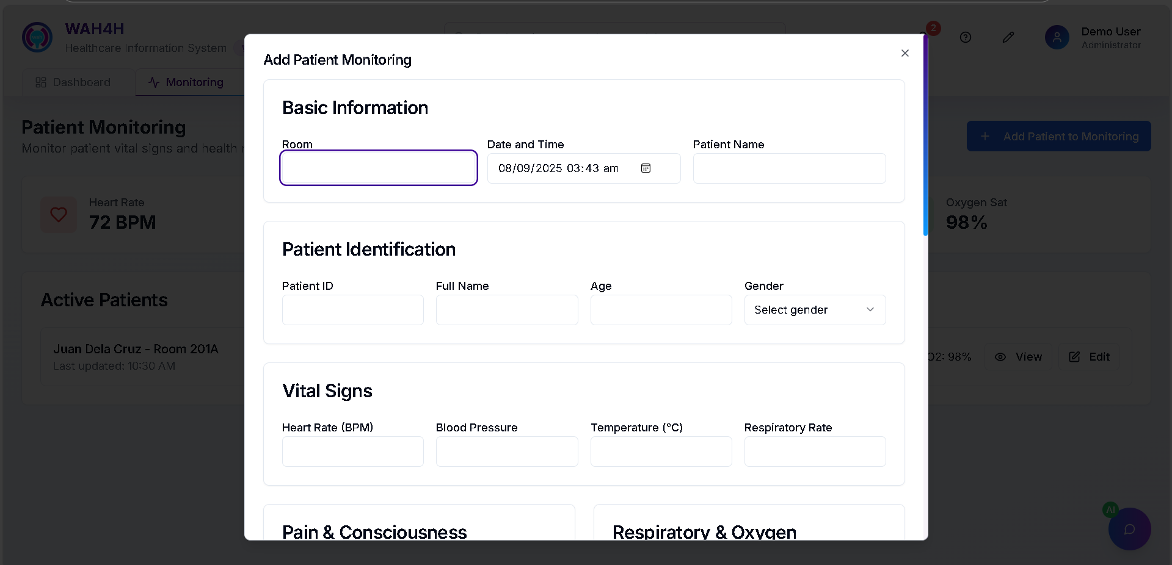

Figure 43: Mockup Design for Add Patient Monitoring

### **Discharge Module (Active Discharges)**

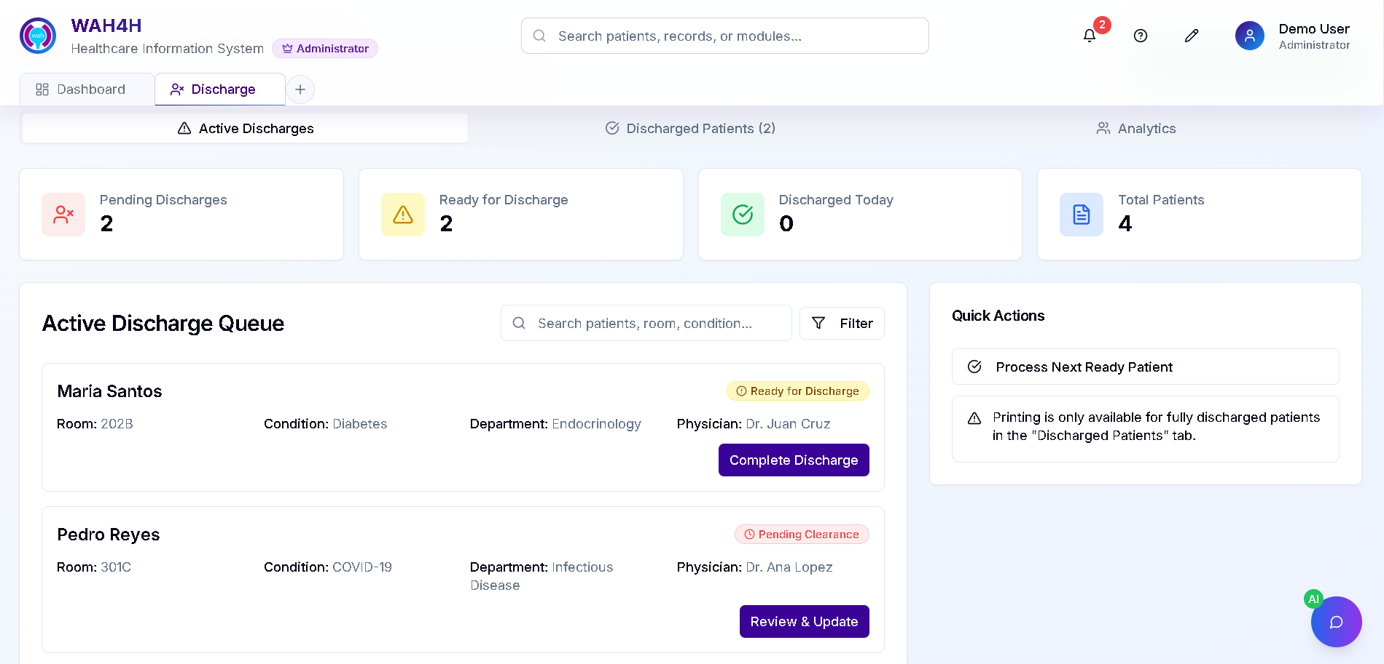

Figure 44: Mockup Design for Discharge

### **Discharge Module (Discharged Patients)**

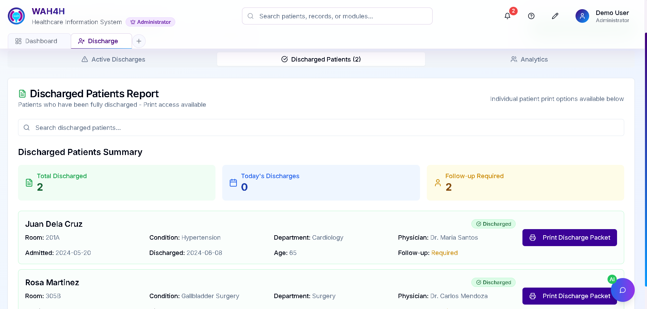

Figure 45: Mockup Design for Discharged Patients

### **Discharge Module (Discharged Patients – Print Discharge Packet)**

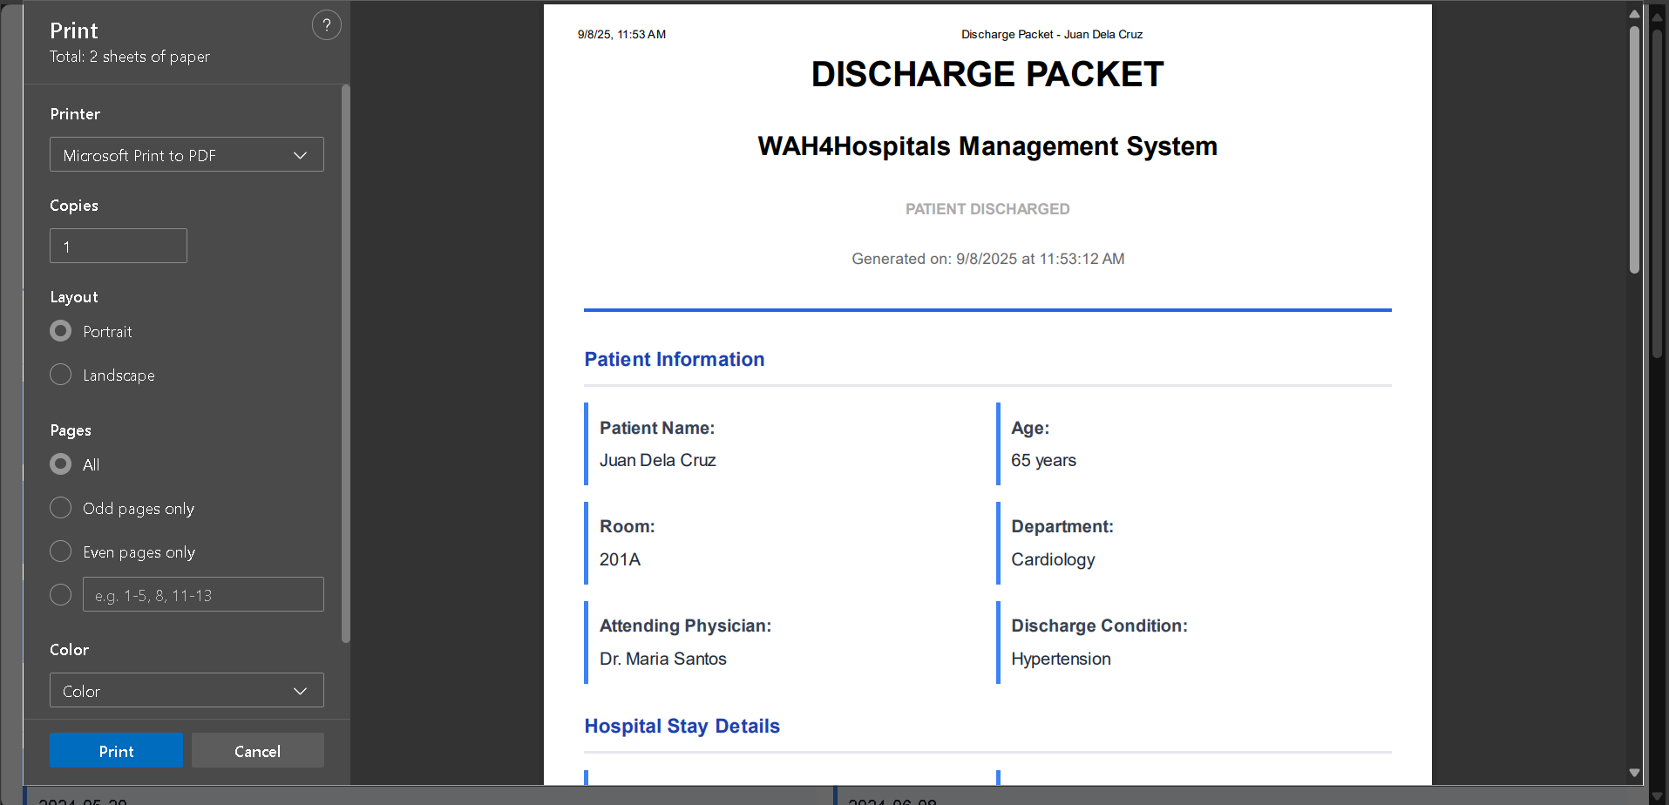

Figure 46: Mockup Design for Print Discharge Packet

### **Discharge Module (Discharged Patients Analytics)**

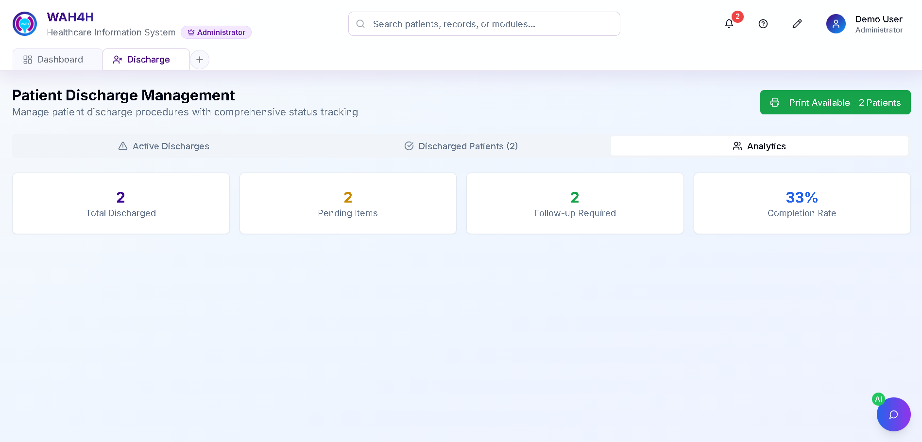

Figure 47: Mockup Design for Discharge Analytics

### **Billing Management Module**

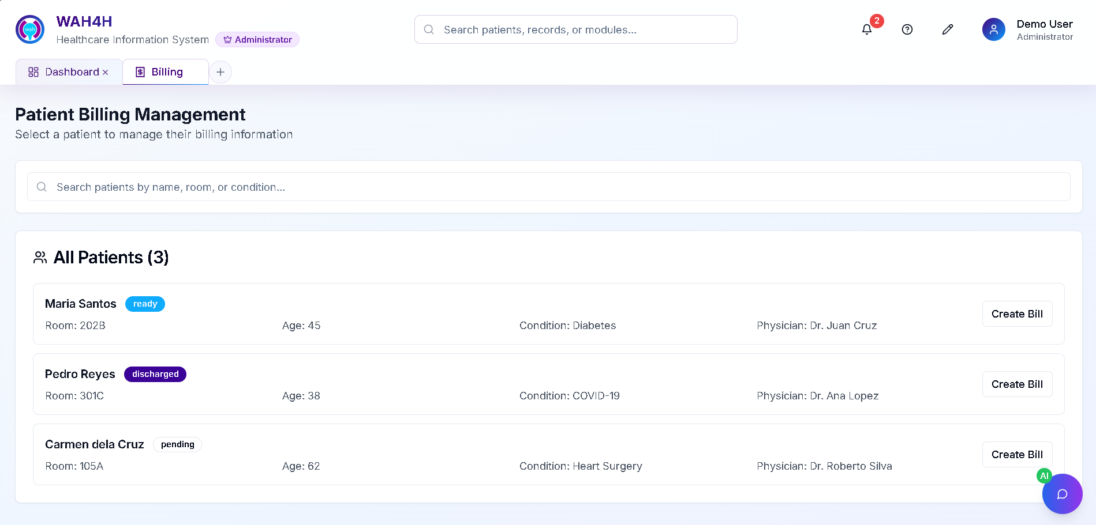

Figure 48: Mockup Design for Billing Management

### **Billing Management Module (Hospital Billing Record)**

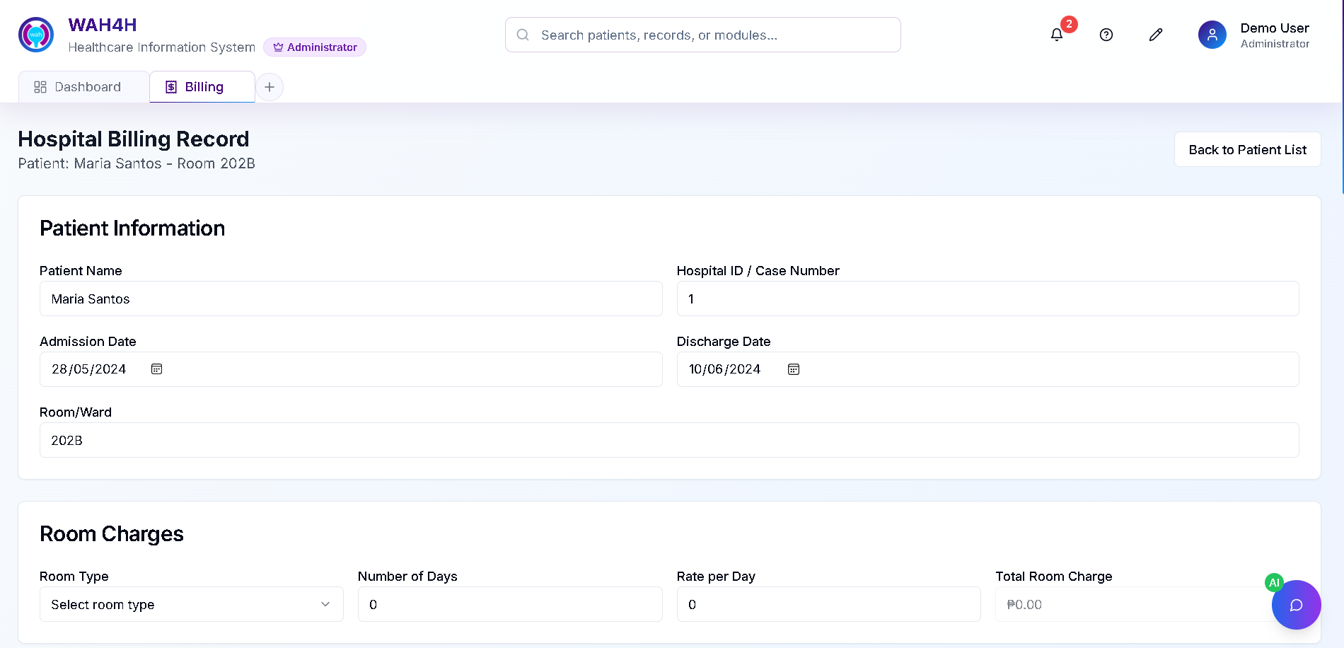

Figure 49: Mockup Design for Hospital Billing Record

### **Settings & Control Panel Module (Security)**

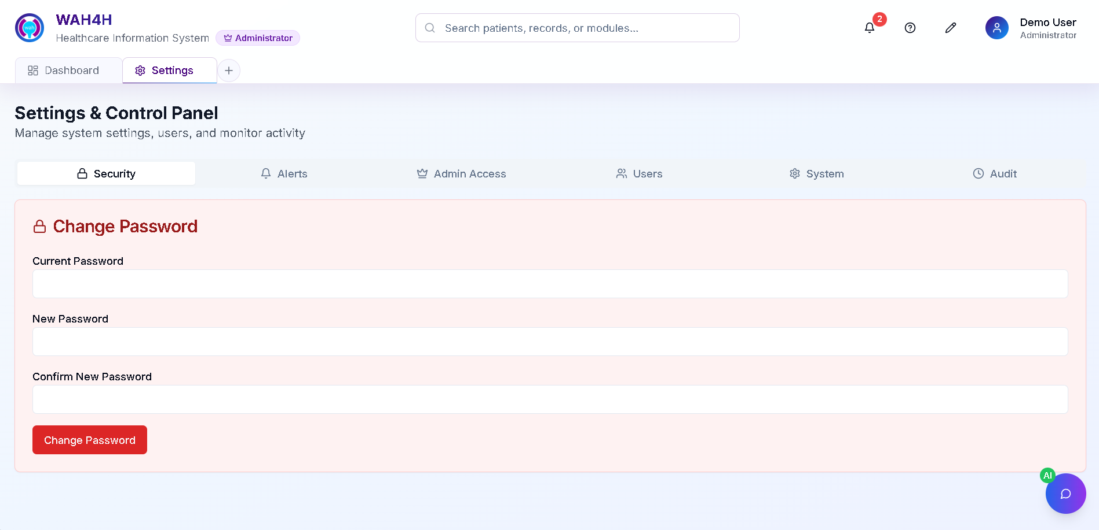

Figure 50: Mockup Design for S&CP Security

### **Settings & Control Panel Module (Alerts)**

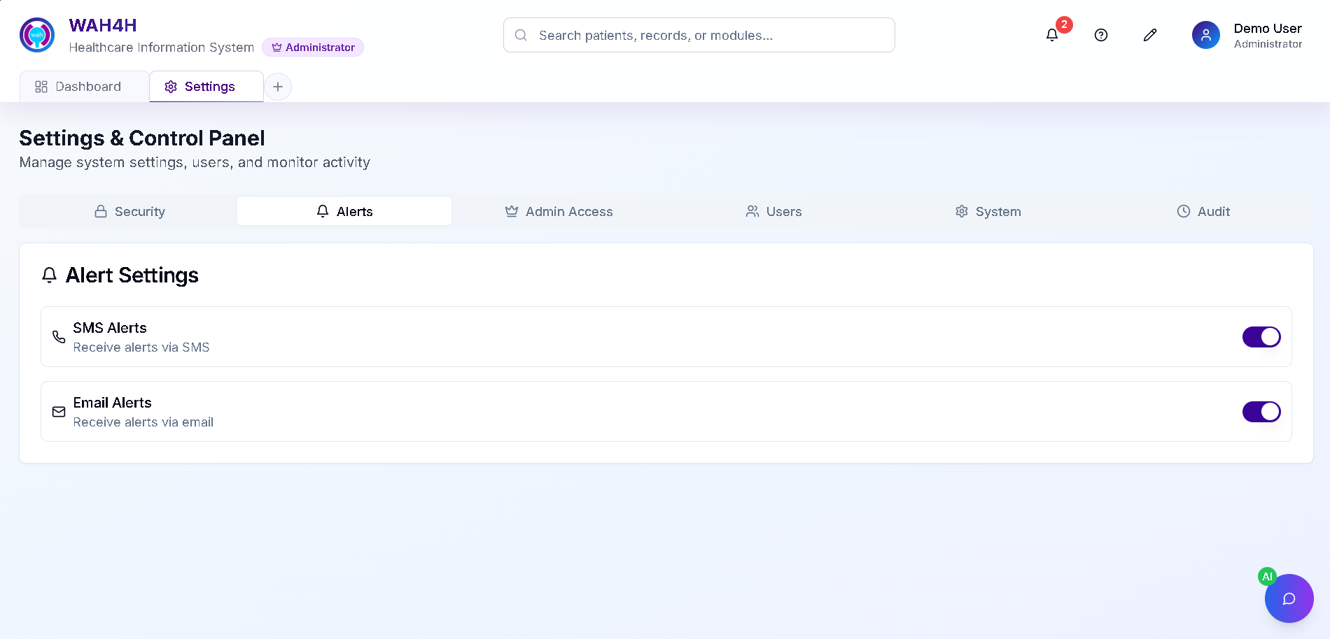

Figure 51: Mockup Design for S&CP Alerts

### **Settings & Control Panel Module (Admin Access)**

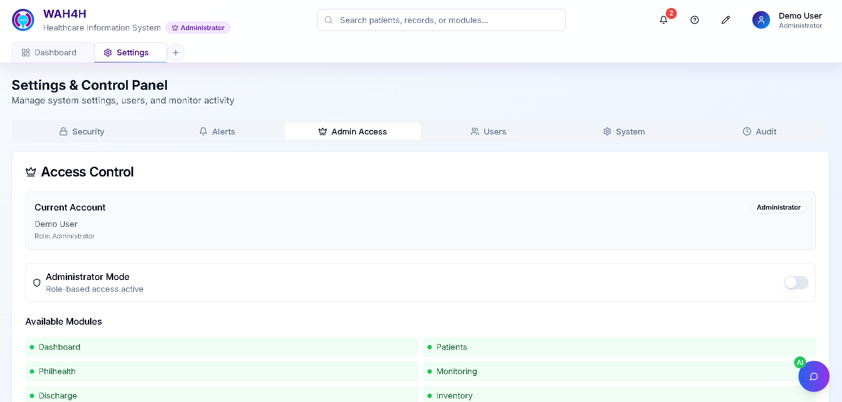

Figure 52: Mockup Design for S&CP Admin Access

### **Settings & Control Panel Module (Users)**

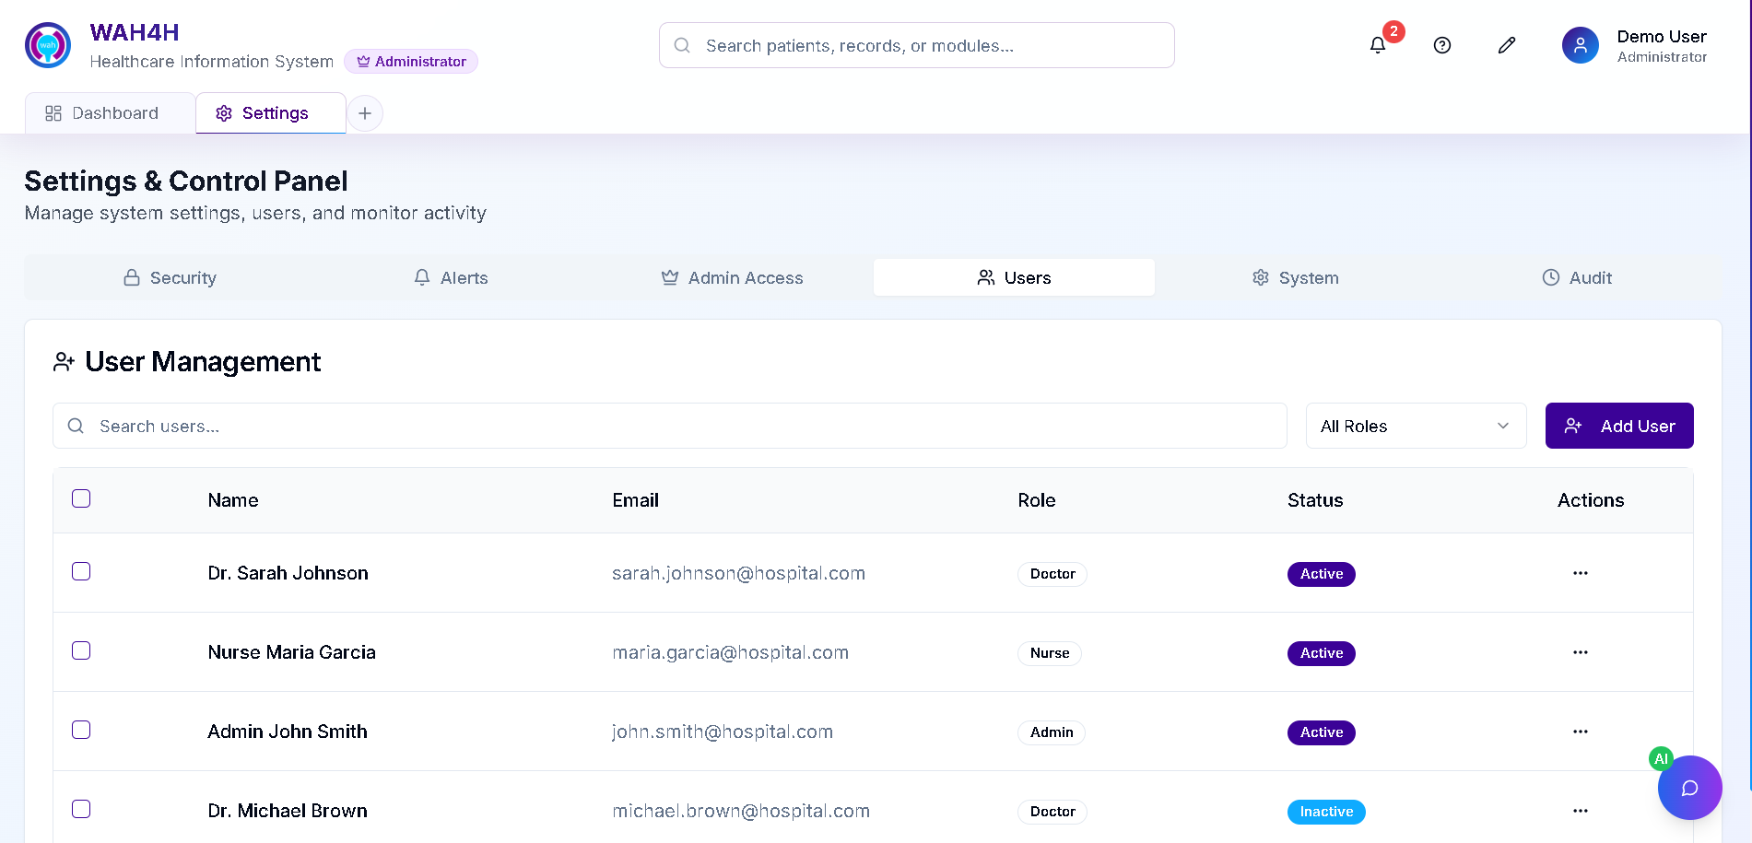

Figure 53: Mockup Design for S&CP Users

### **Settings & Control Panel Module (System)**

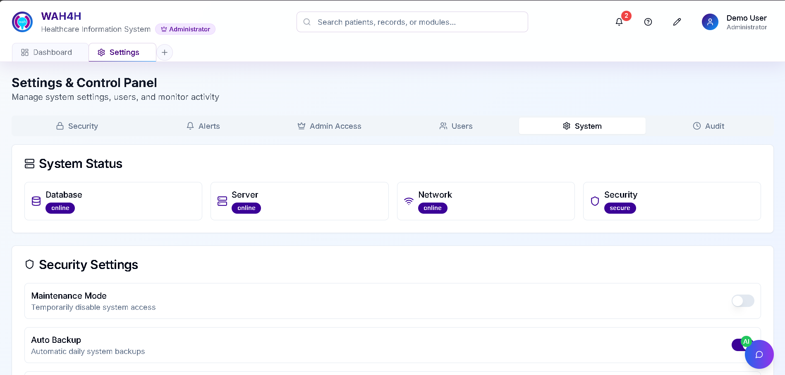

Figure 54: Mockup Design for S&CP System

### **Settings & Control Panel Module (Audit)**

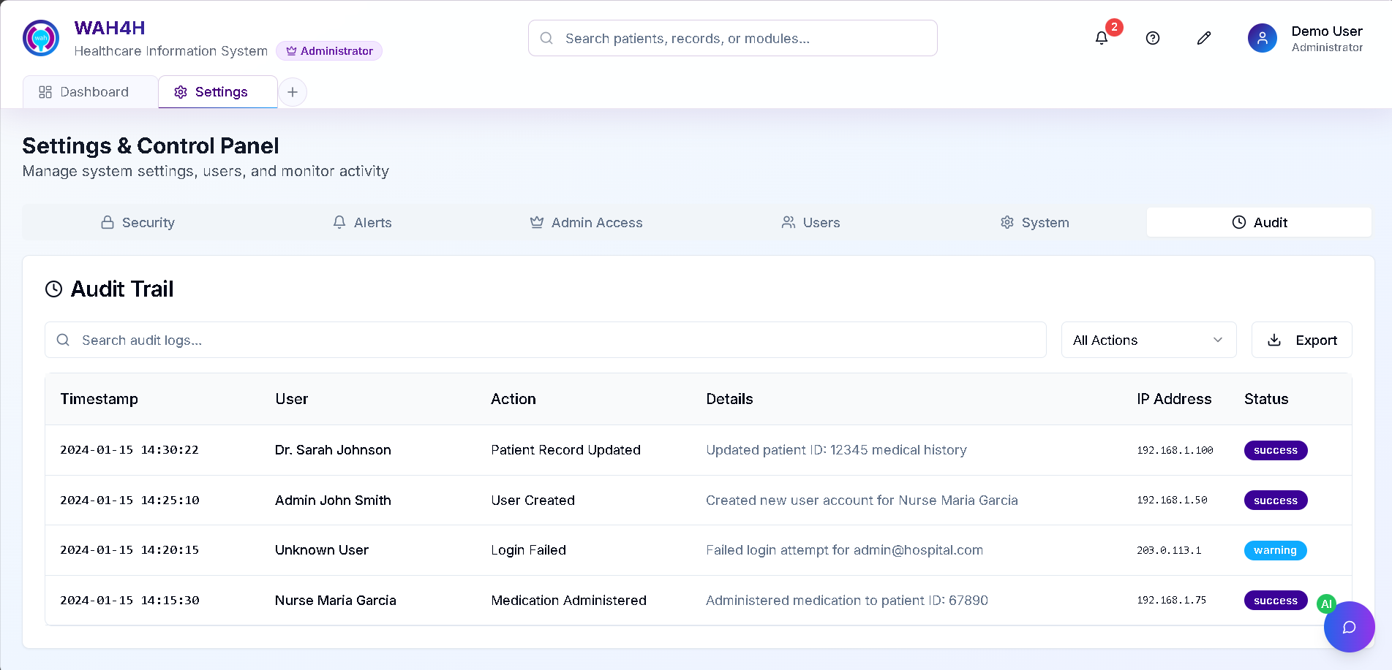

Figure 55: Mockup Design for S&CP Audit

### **Account Settings**

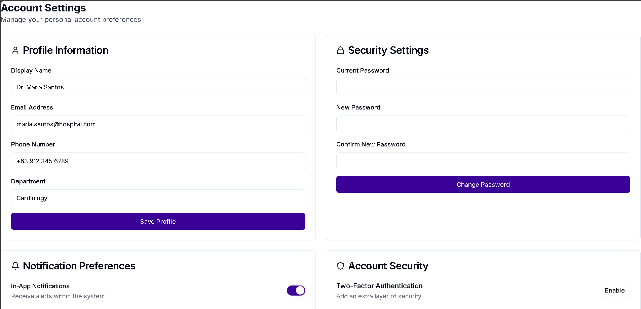

Figure 56: Mockup Design for Account Settings

## **Conclusion**

In summary, the fourth stage of the Design Thinking process serves as a vital step in transforming ideas into workable solutions. Through prototyping, we create early models that can be tested and refined in partnership with our stakeholders. For this project, our efforts are directed toward addressing the unique challenges of Wireless Access for Health (WAH) and Cuyapo Infirmary, ensuring that the system we design is responsive to their needs. By engaging closely with healthcare staff and administrators, we gather input not only on system functionality but also on usability and design preferences, allowing the solution to reflect both practicality and local context.

This stage allows us to bridge the distance between conceptual thinking and real-world application. It gives us the opportunity to identify pain points, explore alternatives, and refine the design so that the end product is not just functional but also meaningful to those who will use it. Ultimately, this process ensures that our solution strengthens WAH’s mission of advancing digital health while supporting Cuyapo Infirmary’s commitment to providing efficient, patient-centered care.

# Stage 5: Testing

In the design thinking process, Stage 5 is typically called the "Test" stage. The Test stage is the final phase of the design thinking process, following the Prototype stages. In this stage, our focus shifts from creating prototypes to testing those prototypes with real users to gather feedback and insights. The primary goal of the Test stage is to ensure that the proposed solutions meet user needs, are user-friendly, and effectively address the identified problem or challenge. We collect qualitative and quantitative feedback from users. This feedback is essential for identifying what works well, what needs improvement, and any unexpected issues or challenges.

# Feedback and Testing with Cuyapo Infirmary Staff

During the onsite scoping activity at Cuyapo Infirmary on **May 14**, the project team presented a working prototype of the WAH4H system to the stakeholders from Wireless Access for Health (WAH). During this early demonstration, the stakeholders provided their general inputs in a discussion-oriented manner rather than through a formal evaluation.

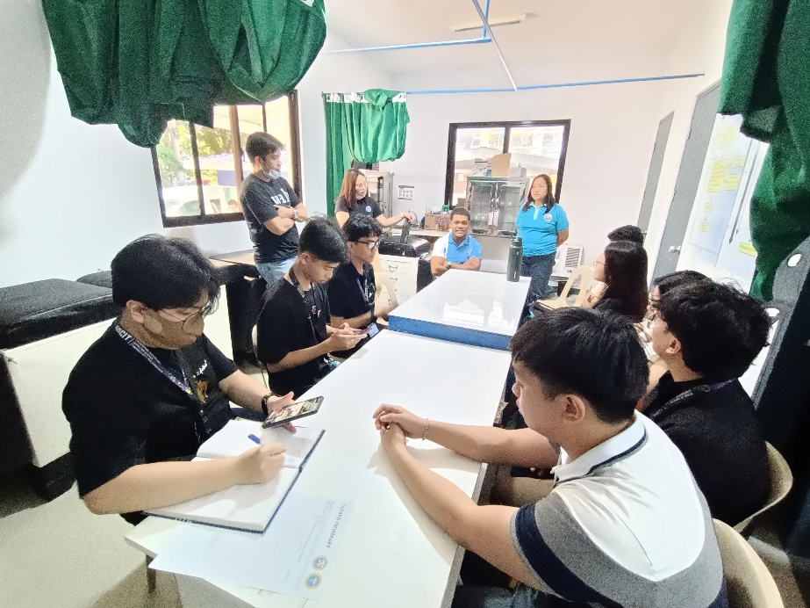

*Figure 57. Feedback and Testing with Cuyapo Infirmary*

# Client Feedback

From this session, several key points of feedback were noted:

* **Positive reception of UI and design:** The stakeholders appreciated the clean, intuitive, and user-friendly interface of the system. They emphasized that the design was more accessible compared to other HIS solutions currently available in the market.
* **Ease of navigation:** The prototype was seen as easier to navigate than competing systems, which they considered an advantage for user adoption, particularly for staff with varying levels of technical comfort.
* **Recommendation for additional modules:** The stakeholders expressed that while the current core modules addressed essential hospital workflows, additional modules would further strengthen the system’s capacity and value for healthcare facilities.

This feedback validated the design choices made in the prototype while also highlighting opportunities for expansion. The positive reaction to the interface and navigation confirms that the system is aligned with the goal of usability, while the call for additional modules signals a need for scalability and adaptability to diverse hospital requirements.

# Group Related Project Artifact

## **Project Artifact**

# **Online Forms Stage 1 Empathize**

[**https://asiapacificcollege.sharepoint.com/:f:/s/SSYADD1SS231T1AY2025-2026/ErT6jcK-2zVLlPjSdKvbF9UBVxfhex8mjXzZKsAzkv-qTA?e=DCkRSV**](https://asiapacificcollege.sharepoint.com/:f:/s/SSYADD1SS231T1AY2025-2026/ErT6jcK-2zVLlPjSdKvbF9UBVxfhex8mjXzZKsAzkv-qTA?e=DCkRSV)

## **Online Video**

## **Stage 1 Empathize**

### [**https://asiapacificcollege.sharepoint.com/:v:/r/sites/SSYADD1SS231T1AY2025-2026/Shared%20Documents/G04%20Pseudoers/Recordings/MEETING%205%20-%20MOTM%205.mp4?csf=1&web=1&e=98fUKw&nav=eyJyZWZlcnJhbEluZm8iOnsicmVmZXJyYWxBcHAiOiJTdHJlYW1XZWJBcHAiLCJyZWZlcnJhbFZpZXciOiJTaGFyZURpYWxvZy1MaW5rIiwicmVmZXJyYWxBcHBQbGF0Zm9ybSI6IldlYiIsInJlZmVycmFsTW9kZSI6InZpZXcifX0%3D**](https://asiapacificcollege.sharepoint.com/:v:/r/sites/SSYADD1SS231T1AY2025-2026/Shared%20Documents/G04%20Pseudoers/Recordings/MEETING%205%20-%20MOTM%205.mp4?csf=1&web=1&e=98fUKw&nav=eyJyZWZlcnJhbEluZm8iOnsicmVmZXJyYWxBcHAiOiJTdHJlYW1XZWJBcHAiLCJyZWZlcnJhbFZpZXciOiJTaGFyZURpYWxvZy1MaW5rIiwicmVmZXJyYWxBcHBQbGF0Zm9ybSI6IldlYiIsInJlZmVycmFsTW9kZSI6InZpZXcifX0%3D)

## **Stage 2 Define**

## **Stage 3 Ideate**

[**https://asiapacificcollege.sharepoint.com/:v:/s/SSYADD1SS231T1AY2025-2026/EWLiJkyQMqVJqNJ1_devB68BziJew97y8HOjn3gL9fE0hA?e=BlFNcR**](https://asiapacificcollege.sharepoint.com/:v:/s/SSYADD1SS231T1AY2025-2026/EWLiJkyQMqVJqNJ1_devB68BziJew97y8HOjn3gL9fE0hA?e=BlFNcR)

## **Stage 4 Prototype**

## **Stage 5 Testing**

# Individual Contributions

## **Jhon Lloyd R. Nicolas**

### Stage 1

* Charter
* DFD
* Communication with WAH
* Information gathering
* Facilitating meetings
* Prototype development

### Stage 2

* Lorem Ipsum

### Stage 3

* Lorem Ipsum

### Stage 4

* Lorem Ipsum

### Stage 5

* Lorem Ipsum

## **Elijah Josh R. Quibin**

### Stage 1

* Objectives
* Use Case Diagram
* Initial Scoping
* Communication with Cuyapo Infirmary
* Stage 1 Empathize Interview
* Storyboard
* Theoretical Persona
* SSYADD Paper
* Facilitating Meetings

### Stage 2

* Lorem Ipsum

### Stage 3

* Lorem Ipsum

### Stage 4

* Lorem Ipsum

### Stage 5

## **John Kenneth L. Jajurie**

### Stage 1

* Stakeholder Analysis
* SSYADD Paper
* Facilitating Meetings
* Prototype Development

### Stage 2

* Lorem Ipsum

### Stage 3

* Lorem Ipsum

### Stage 4

* Lorem Ipsum

### Stage 5

* Lorem Ipsum

## **Mariyah Vanna Monique C. Chavez**

### Stage 1

* Scope
* OpenProject Management
* Storyboard
* Actual Persona
* Documents Organization
* Facilitating Meetings

### Stage 2

* Lorem Ipsum

### Stage 3

* Lorem Ipsum

### Stage 4

* Lorem Ipsum

### Stage 5

* Lorem Ipsum